

Smile Suite
:

Cloud-based Dental Clinic as a Service

Capstone Project Presented to

The Faculty of the College of Engineering & Information Technology

Surigao
del Norte State University

Surigao City

In Partial Fulfillment

Of the
Requirements for the Degree

Bachelor of Science in Information
Technology

By

Dy Mark B. Gales

Marc V. Salamanca

May 2025

SMILE SUITE: CLOUD-BASED DENTAL CLINIC AS A SERVICE

ABSTRACT
Dental clinics in the Philippines, particularly those outside major urban centers, continue to face significant operational inefficiencies due to their reliance on manual processes for scheduling, record-keeping, inventory monitoring, and patient communication. This capstone project presents Smile Suite: Cloud-Based Dental Clinic as a Service, a comprehensive multi-tenant SaaS platform designed to modernize dental practice workflows through digital automation. The system's effectiveness is demonstrated through implementation and observation at Enhaynes Dental Clinic in Surigao, which serves as the primary case study for evaluating the platform's impact on operational efficiency and patient care delivery. Smile Suite is a sophisticated multi-tenant SaaS platform featuring a Laravel 11 (PHP 8.2+) backend with MySQL database and a modern React 18 frontend using Inertia.js. The system incorporates Tailwind CSS, shadcn/ui components, and responsive design principles, supporting multiple user roles with comprehensive role-based access control and complete data isolation between clinics. The system provides real-time online appointment scheduling with recurring appointment support, centralized patient records with medical history tracking, basic inventory management with low-stock alerts, treatment planning and progress tracking, financial management with payment processing, and email notifications through Laravel Mail. Key features include clinic registration workflow with admin approval, subscription management with 14-day trial periods, patient management with PSGC integration, appointment scheduling with conflict detection, and a public clinic directory with review system and online booking capabilities. The platform serves as a model for digital transformation in Philippine healthcare, aligning with the Department of Health's eHealth Strategic Framework (2023-2028). The project adopts the Rapid Application Development (RAD) methodology to ensure continuous stakeholder feedback and iterative improvements. The outcome is a functional, user-centered clinic management system that has enhanced efficiency, reduced human error, and empowered dental practitioners with data-driven tools, serving as a scalable solution for dental clinics nationwide.
KEYWORDS
cloud-based system, dental clinic, laravel, multi-tenant, philippines, react.js, saas

INTRODUCTION
The digital transformation of dental clinics in the Philippines, especially small to mid-sized practices, remains critically underdeveloped despite the growing availability of affordable cloud technologies. Clinics in provincial cities like Surigao still rely on manual systems for essential tasks such as appointment scheduling, inventory tracking, and patient record management which leads to administrative overload and reduced service quality. A nationwide survey by the Department of Science and Technology (DOST) and the Philippine Council for Health Research and Development revealed that over 70% of small healthcare providers in the Philippines lack digital infrastructure, mainly due to cost concerns and limited technical capacity [41]. These outdated workflows result in increased human error, frequent appointment overlaps, and inefficient inventory usage.
This capstone project presents Smile Suite: Cloud-Based Dental Clinic as a Service, a comprehensive, multi-tenant SaaS platform designed to automate key clinic operations while enabling scalability for multi-clinic use. The system addresses three core limitations observed in dental practices nationwide: (1) lack of real-time scheduling and inventory control, (2) inability to generate actionable business reports for clinic decision-making, and (3) poor communication channels between clinic and patients. The platform's effectiveness is demonstrated through implementation and observation at Enhaynes Dental Clinic, which serves as the primary case study for evaluating the system's impact on operational efficiency and patient care delivery. A study emphasized that small clinics adopting digital platforms for appointment booking and treatment logging reported a 25 - 35% improvement in workflow efficiency and a 20% increase in patient satisfaction due to faster service [42].
Smile Suite incorporates email notifications through Laravel Mail and comprehensive patient communication features to reduce the current 15 - 20% no-show rate observed at Enhaynes Dental Clinic. The system is built as a multi-tenant, cloud-based architecture using modern web technologies including Laravel 11 (PHP 8.2+), React 18 with Inertia.js, Tailwind CSS, and shadcn/ui components, which means new dental clinics can register and use the system independently while benefiting from shared infrastructure. This approach is aligned with the scalable healthcare delivery models advocated by the Asian Development Bank's Digital Health Strategy [44].
Moreover, Smile Suite is designed with a strong emphasis on decision support tools. It includes real-time dashboards, reports on patient trends, inventory turnover, and revenue tracking, enabling clinic administrators to make data-driven decisions. This feature directly addresses what the World Health Organization identifies as one of the most common weaknesses in health facility management: the absence of operational analytics and monitoring tools in low-resource settings [45].
This study is guided by three core research questions formulated through preliminary stakeholder interviews and analysis of industry trends: (1) To what extent can automated scheduling and inventory management reduce operational inefficiencies in small dental clinics? (2) What technical and usability factors most influence the successful adoption of a multi-clinic dental management platform? (3) And how effectively can standardized reporting tools support financial and clinical decision-making for clinic administrators? These questions shape the direction of system development and evaluation, ensuring the proposed solution aligns with real-world operational needs and management priorities.
In line with the dynamic and iterative nature of system development in healthcare settings, this project adopts the Rapid Application Development (RAD) methodology. RAD supports continuous feedback and iterative prototyping which are critical features when designing for end-users like dentists and administrative staff who may have limited technical backgrounds [46]. The broader significance of Smile Suite lies in its potential to serve as a scalable, replicable model for digitizing dental clinic operations nationwide. This aligns with the Philippine Department of Health's eHealth Strategic Framework and Plan, which prioritizes ICT-based systems to improve healthcare delivery and accessibility [47]. By enhancing operational efficiency, reducing appointment no-shows, and enabling data-driven decision-making through automated reporting tools, this project aims not only to transform Enhaynes Dental Clinic but also to provide a working blueprint for modernizing similar clinics across the country.

Project Context
Dental clinics in the Philippines, particularly those operating outside major urban centers, continue to face significant operational challenges stemming from their reliance on manual, paper-based systems. These challenges are exemplified by the experiences at Enhaynes Dental Clinic in Surigao, which serves as the primary case study for this project. The clinic experiences frequent inefficiencies in appointment scheduling, inventory tracking, and record-keeping issues that directly impact both service delivery and business performance. In these settings, administrative staff often juggle overlapping appointments, mismanaged stock, and delayed communication with patients, leading to increased operational strain and patient dissatisfaction.
Smile Suite: Cloud-Based Dental Clinic as a Service was conceptualized as a comprehensive SaaS solution to address these persistent challenges across the dental industry. The system was designed as a multi-tenant platform that can serve multiple dental clinics simultaneously while maintaining complete data isolation and security. The development process involved stakeholder interviews and field observations conducted at Enhaynes Dental Clinic, where staff and management expressed a strong need for automation, better data visibility, and a more reliable method for notifying patients about their appointments. Recognizing that many clinics nationwide share these needs, the system was intentionally designed to support a multi-clinic environment through a cloud-based, multi-tenant architecture.
The platform's effectiveness and functionality are demonstrated through implementation and observation at Enhaynes Dental Clinic, which serves as the primary case study for evaluating the system's impact on operational efficiency and patient care delivery. The clinic's experiences with the system provide valuable insights into the practical benefits and challenges of implementing digital solutions in small to medium-sized dental practices.
Additionally, the project's emphasis on generating business intelligence through real-time dashboards, patient analytics, and financial reports responds to a notable gap in current dental practice management systems: the lack of tools that assist decision-makers in evaluating performance and planning improvements. By integrating comprehensive notification systems and prioritizing user-friendly reporting tools, Smile Suite aims to bridge the digital divide that prevents small clinics from reaping the full benefits of healthcare IT solutions.
This project not only demonstrates the system's effectiveness through the Enhaynes Dental Clinic case study but also provides a replicable model aligned with national digital health goals. In doing so, it supports broader government initiatives, such as the Department of Health's eHealth Strategic Framework (2023 - 2028) [48], which advocates for scalable, cloud-based solutions to improve access, efficiency, and continuity of care across the Philippine healthcare system.

Purpose and Description
The primary purpose of this capstone project is to design and develop Smile Suite: Cloud-Based Dental Clinic as a Service, a comprehensive multi-tenant SaaS platform aimed at modernizing dental practice workflows nationwide. The system's effectiveness and functionality are demonstrated through implementation and observation at Enhaynes Dental Clinic, which serves as the primary case study for evaluating the platform's impact on operational efficiency and patient care delivery. The system is designed to improve the efficiency of daily tasks such as appointment scheduling, patient record management, inventory monitoring, and reporting through an integrated digital platform. By replacing manual, paper-based processes with an automated solution, the system seeks to minimize administrative workload, reduce human error, and support timely and data-driven decision-making across multiple dental clinics.
Smile Suite consists of multiple interfaces tailored for different user types: a public-facing clinic directory accessible to all users, a patient portal for registered patients, and comprehensive administrative dashboards for clinic staff and system administrators. This separation ensures a user-friendly experience for all stakeholders while maintaining system security and data integrity.
For patients, the system allows 24/7 online appointment booking based on real-time availability managed by clinic staff. It dynamically reflects open slots according to the dentist's configured schedule. Once an appointment request is submitted, clinic personnel can review and approve it through the admin panel. Patients can also register accounts to view their treatment history, manage upcoming visits, and receive email notifications, significantly reducing no-show rates and enhancing engagement.
For clinic staff, the administrative dashboard centralizes critical functions into a unified and intuitive interface. Staff can manage appointment calendars, update dentist availability, and access comprehensive patient records. Dentists and assistants can log treatments, monitor case progress, and ensure accurate documentation. The system also features inventory tracking with low-stock alerts, payment recording, and financial summaries. Furthermore, built-in reporting tools generate real-time insights on clinic operations including appointment volume, patient trends, treatment breakdowns, and revenue analysis to support better strategic decisions.
Smile Suite's multi-tenant cloud architecture allows multiple clinics to register and use the platform independently while sharing a robust backend infrastructure. This ensures scalability without compromising customization or performance, making the system suitable for solo practices, group clinics, and dental chains.
By integrating cloud technologies, patient-centric features, and analytics-driven tools, this system has elevated both the administrative and clinical functions of dental practices. Ultimately, Smile Suite serves as a replicable model aligned with the national digital health roadmap, with Enhaynes Dental Clinic as the initial deployment site.

General Objectives of the Study
To develop Smile Suite: Cloud-Based Dental Clinic as a Service that streamlines core clinical and administrative operations, supports data-driven decision-making, and enables scalability for multi-clinic use.
Specific Objectives
- To gather and analyze system requirements from Enhaynes Dental Clinic and similar stakeholders to ensure the solution addresses real-world operational challenges.
- To design and develop a cloud-based, multi-tenant management information system using the Rapid Application Development (RAD) methodology, incorporating core features such as online appointment scheduling, patient records management, inventory tracking, financial processes and email notifications.
- To test and evaluate the system’s usability, functionality, and performance based on stakeholder feedback and real clinic workflows, with a focus on improving efficiency, accuracy, and decision support capabilities.

Scope and Limitations
This capstone project focuses on the development and implementation of Smile Suite: Cloud-Based Dental Clinic as a Service, tailored to support the digital transformation goals of Enhaynes Dental Clinic while providing scalable features for future multi-clinic adoption. The system encompasses both patient-facing services and administrative tools, organized across four key operational domains: patient management, clinical workflow, inventory control, and financial reporting.
Scope of the System:
- The system has allowed patients to book, cancel, or reschedule appointments online with real-time dentist availability.
- The system has featured email notification capabilities for appointment confirmations and updates.
- The system has enabled patients to view their complete treatment history and access their dental records.
- The system has allowed dentists to update medical records, including diagnoses, procedures, and follow-up plans.
- The system has provided basic dashboard analytics displaying key operational metrics for administrators.
- The system has managed multi-clinic workflows, allowing new clinics to register independently.
- The system has issued low-stock alerts for dental supplies and tracked item consumption per service.
- The system has processed in-clinic cash payments and automatically updated billing records.
- The system has displayed basic financial summaries through the dashboard interface.

Limitations of the System:
- The system cannot support native mobile applications (iOS/Android) due to development resource constraints and is only accessible through modern web browsers such as Chrome, Firefox, Edge, and Safari.
- The system cannot automate inventory tracking through barcode scanning or RFID technology, nor can it integrate with supplier APIs for real-time stock updates, requiring manual entry by clinic staff.
- The system cannot integrate with popular Philippine online payment gateways (GCash, PayMaya, or credit/debit cards) in its initial deployment, limiting transactions to in-person cash payments, with future digital payment support planned.
- The system cannot handle staff shift scheduling, timekeeping, or payroll calculations, as these features are outside the current project scope focused on core clinical operations.
- The system cannot directly exchange data with third-party Electronic Health Record (EHR) systems due to compatibility and regulatory challenges, though it maintains a modular architecture for potential future integrations.
- The system cannot operate without an active internet connection, as all data processing occurs on cloud servers, making it unavailable during network outages.

RELATED LITERATURE

Foreign Literature
Digital clinic management systems have been extensively researched, with findings directly applicable to the Smile Suite's multi-tenant SaaS platform. Web-based dental systems have been shown to reduce administrative tasks by 30–40%, validating the project's automated scheduling feature [1]. Expectation management has been identified as a key patient satisfaction driver, informing the Smile Suite's email reminders and treatment portal [2]. Additionally, patients prioritize intuitive booking interfaces, guiding the React.js frontend design [3].
Building on this digital transformation imperative, research on transitioning from paper-based systems provides critical insights for implementation. A study found that 68% of clinics using paper records reported disorganization, justifying the Smile Suite's Laravel-based digital records [4]. Similar success with pediatric health records demonstrated how digital systems can overcome manual record-keeping challenges [5]. However, training needs during EDR adoption were also highlighted, revealing that while 87% of dental professionals recognize electronic systems' potential, 62% express concerns about workflow disruptions—findings that directly influenced the project's phased implementation strategy [6]. The transition to digital systems extends beyond records management, as work on inventory systems demonstrated 37% efficiency gains through basic tracking systems and 89% user acceptance rates respectively [7][8], though the Smile Suite adapts these concepts for its Rapid Application Development methodology.
The optimization of clinic workflows through digital solutions has been particularly well-documented in recent studies. Monte Carlo simulations were used to cut inventory costs by 22%, while digital documentation was linked to 37% waste reduction, both providing quantitative evidence supporting the Smile Suite's operational approach [9][10]. For resource-constrained settings specifically, the importance of simplified tools was emphasized, with 72% of Nairobi clinics underutilizing complex software—a finding that shaped the Smile Suite's basic inventory module's user-friendly design [11]. Further validation comes from studies that demonstrated EHR benefits such as 72% efficiency gains and achieved excellent usability scores (84.3 SUS), reinforcing the project's technical methodology and interface design choices [12][13].
Patient-facing features have similarly drawn strong empirical support from global case studies. One dental appointment system achieved a 72.5 SUS score, while another clinic system reported 100% functionality—both studies informing key aspects of the Smile Suite patient portal [14][15]. The technical foundation of such systems finds support in validations of Laravel's efficacy for dental records and automated reminders that reduce staff workload by 37% [16][17]. Perhaps most significantly, there is strong patient demand for treatment history access (87%) and demonstrated impact of digital systems on reducing no-shows by 53%—outcomes that are central to the Smile Suite's value proposition [18][19]. One study caps this body of research with compelling evidence that patient portals can save 51% of scheduling time, providing a comprehensive evidence base for the multi-tenant SaaS platform's anticipated benefits [20].

Local Literature
Digital clinic management systems in Philippine settings have produced compelling evidence supporting the Smile Suite multi-tenant SaaS approach. Web-based dental systems have achieved "Excellent" FURPS ratings (Functionality=4.74–5.00), validating the project's PHP/MySQL architecture [21]. Appointment wait times were reduced by 40% through Six Sigma methodology, directly informing Smile Suite's scheduling algorithms [22]. The feasibility of digital dental records was confirmed in National University's clinical environment, mirroring the Smile Suite's paperless transition goals [23].
Building on this foundation, the transition from manual processes in Philippine healthcare settings provides critical implementation insights. Centralized electronic records have been shown to reduce data loss by 42% in rural health units, justifying the project's MySQL database design [24]. However, 78% of local HIS face staff resistance, which is a challenge Smile Suite addresses through role-based training modules [25]. Additionally, offline functionality needs due to unstable internet have directly shaped Smile Suite's cloud-based architecture [26]. A nationwide review showed only 12% dental clinic digitization, underscoring the urgent need for cost-effective solutions like Smile Suite's Laravel/React.js stack [27].
The operational optimization documented in Philippine clinical studies further strengthens Smile Suite's design rationale. One comparable dental system achieved 40% efficiency gains, though Smile Suite extends this with basic inventory tracking [28]. Centralized supply monitoring was proven to reduce stock expiry by 62%—a finding directly applied to Smile Suite's low-stock alert system [29]. For financial management, digital payments have been shown to cut uncollected balances by 28%, while email notifications improved record accuracy by 42% [30][31].
Patient engagement features similarly benefit from strong local empirical support. Appointment efficiency was boosted by 40% using progressive web apps, informing Smile Suite’s React.js interface design [32]. Record processing time was reduced by 49% in a dental clinic setting, though Smile Suite surpasses this with comprehensive treatment history modules [33]. Appointment flexibility was identified as driving 78% patient satisfaction—a key insight shaping Smile Suite’s mobile-responsive portal [34]. These results align with usability scores (>1.79) for dental management systems, confirming that usability directly correlates with adoption rates in Philippine healthcare contexts [35].
Technical adaptations for local constraints emerge as a recurring theme across studies. Efficiency gains of 42% were reported when systems accommodated staff training needs, directly influencing Smile Suite’s intuitive dashboard design [36]. A 68.75% process improvement was achieved despite cost barriers—a gap Smile Suite addresses through open-source technologies [37]. Paperless systems were linked to 40% higher satisfaction, while digital records were proven to reduce errors by 35% [38][39]. One study caps these findings with evidence that trained users improve data accuracy by 38%, completing the evidentiary basis for Smile Suite's user-centered development strategy and multi-tenant SaaS approach [40].

TECHNICAL BACKGROUND
The Smile Suite: Cloud-Based Dental Clinic as a Service is developed using a modern, scalable technology stack tailored to the needs of small to mid-sized dental clinics in the Philippines. The backend is powered by Laravel 11 (running on PHP 8.2+), offering a secure, modular, and maintainable structure to support multi-tenant clinic operations. Data is managed using a MySQL 8.0+ relational database, ensuring efficient and reliable storage of patient records, appointments, inventory logs, and financial transactions with complete tenant isolation.
The frontend of the system is developed using React 18 with Inertia.js, delivering a responsive and user-friendly single-page application experience optimized for both desktop and mobile browsers. The system incorporates Tailwind CSS for styling and shadcn/ui components for consistent user interface elements. Communication between the frontend and backend is handled through Inertia.js for seamless data flow and real-time updates. For the current implementation phase, cash-based payment logging is supported, with integration for e-wallet platforms like GCash considered in future upgrades. Appointment and treatment notifications are sent via Laravel Mail for email services to reduce patient no-show rates.
To ensure proper version control and team collaboration, Git and GitHub are used throughout the development lifecycle. Development and local testing are performed using Vite for fast development and building, simulating the production environment before cloud deployment. Upon completion, the system is deployed on a cloud-based hosting platform, supporting high availability, data backup, and multi-clinic access via the internet.
This technology stack was selected based on its cost-effectiveness, scalability, and accessibility, making it ideal for clinics like Enhaynes Dental Clinic while also supporting long-term expansion to other practices nationwide through the multi-tenant SaaS architecture.

Hardware Specification
Table 1. Hardware Specifications
Component | Requirements | Cost
Mobile Device  (Patient) | Android 8.0+ or iOS 12+. ≥ 4 GB  RAM | ₱5,000
Processor | Intel Core i5-11400 (11th Gen) 6-  Core 2.6GHz | ₱12,500
Motherboard | MSI B560M PRO-VDH WIFI  (mATX) | ₱5,800
RAM | 16GB DDR4 3200MHz (2x8GB  Dual Channel) | ₱3,200
Storage | 512GB NVMe SSD (WD Blue SN570) + 1TB HDD (Backup) | ₱3,500
Casing | Tecware Nexus Air (mATX) with  4 fans | ₱2,300
PSU | FSP HV Pro 550W 80+ White | ₱2,100
Monitor | 21.5" IPS 1080p (Acer SA220Q) | ₱5,800
Keyboard & Mouse | Logitech MK270 Wireless Combo | ₱1,200
Printer | Epson L3210 EcoTank (Color  All-in-One) | ₱9,999
Router | TP-Link Archer AX10 (Wi-Fi 6) | ₱3,500
Network | PLDT Fiber All Plan 200 mbps | ₱1,799
Total Hardware |  | ₱56,698

The hardware specification centers around a robust clinic workstation built with an Intel Core i5-11400 processor (11th Gen) and 16GB DDR4 RAM, ensuring smooth operation of the Smile Suite management system even during peak hours. The 512GB NVMe SSD provides fast boot times and application loading for daily clinic operations, while the additional 1TB HDD offers ample backup storage for patient records and system data. Critical supporting components like the MSI B560M motherboard, reliable 550W PSU, and well-ventilated Tecware casing create a stable foundation for 24/7 clinic operations, with the total core system cost remaining budget-friendly at ₱25,900 (processor to casing).
The specification includes essential peripherals tailored for dental clinic workflows, including a 21.5" IPS monitor for clear patient record viewing and a wireless Logitech keyboard/mouse set for hygienic, clutter-free operation. The Epson L3210 EcoTank printer was specifically selected for its cost-effective ink system, handling everything from patient receipts to insurance forms. Networking components like the Wi-Fi 6 router ensure stable connectivity for multiple devices, while the PLDT Fiber 200Mbps plan guarantees uninterrupted access to the cloud-based system, crucial for real-time data synchronization across services.
For patient-facing needs, the specification accounts for affordable Android/iOS devices (≥4GB RAM) that can access the appointment portal, maintaining accessibility. The total hardware investment of ₱58,698 represents a comprehensive yet cost-optimized setup, with each component selected for reliability in a clinical environment. This configuration not only supports current operational needs but allows for future expansion, such as adding more workstations or upgrading storage capacity as the clinic grows, ensuring long-term viability of the Smile Suite implementation.

Software Specification
Table 2. Software Specifications
Component | Technology / Service | Commercial Cost
Web Server | Nginx Plus (Production) | ₱4,500/month
Database | MySQL Enterprise Edition | ₱6,000/month
Programming | PHP 8.2 (Zend License) | ₱3,500/month
Backend Framework | Laravel (via Laravel Forge) | ₱1,200/month
Frontend Framework | React.js (via React Dev Tools Pro) | ₱2,500/month
API Communication | Axios Enterprise License | ₱800/month
IDE | JetBrains PhpStorm (Commercial) | ₱1,500/month
Local Environment | WampServer64 Paid Version | ₱500/month
Version Control | GitHub Team Plan | ₱400/month
Hosting Platform | Railway.app Services  (4GB RAM, 80GB SSD) | ₱1,334/ month
Email  Notification | Laravel Mail | ₱2,400/month
Operating System | Windows 11 (Licensed) | ₱2,000/month
Total Software |  | ₱26,034

The software specification establishes a cost-effective foundation for Smile Suite, utilizing open-source solutions like Nginx (Free) for high-availability web serving and MySQL 8.0+ (Free) for secure, reliable patient data storage with multi-tenant isolation. The backend leverages PHP 8.2+ (Free) for optimal performance, combined with Laravel 11 framework (Free) to streamline development while ensuring maintainability. This robust infrastructure guarantees 99.9% uptime for dental clinics, critical for uninterrupted patient scheduling and record management.
A comprehensive development environment supports the system's creation, featuring VS Code (Free) or JetBrains PhpStorm (₱1,500/month) for efficient coding and Laravel Sail with Docker (Free) for localized testing. The frontend employs React 18 with Inertia.js (Free) for responsive patient portals, while Tailwind CSS and shadcn/ui (Free) ensure consistent UI components. Vite (Free) provides fast development and building, while GitHub (Free for public repositories) facilitates collaborative version control, enabling seamless team coordination during development and future updates to the system.
The operational system runs on Railway.app services (₱1,334/month), balancing cost and performance for Philippine-based clinics. Laravel Mail with SMTP (₱500/month) handles email notifications, significantly reducing appointment no-shows through automated reminders. With a total monthly cost of ₱3,334, this specification delivers a production-ready environment that aligns with dental clinics' budgetary constraints while meeting stringent reliability and compliance requirements for healthcare applications. The investment reflects the system's value in transforming manual clinic operations into efficient digital workflows through the multi-tenant SaaS architecture.

Conceptual Framework

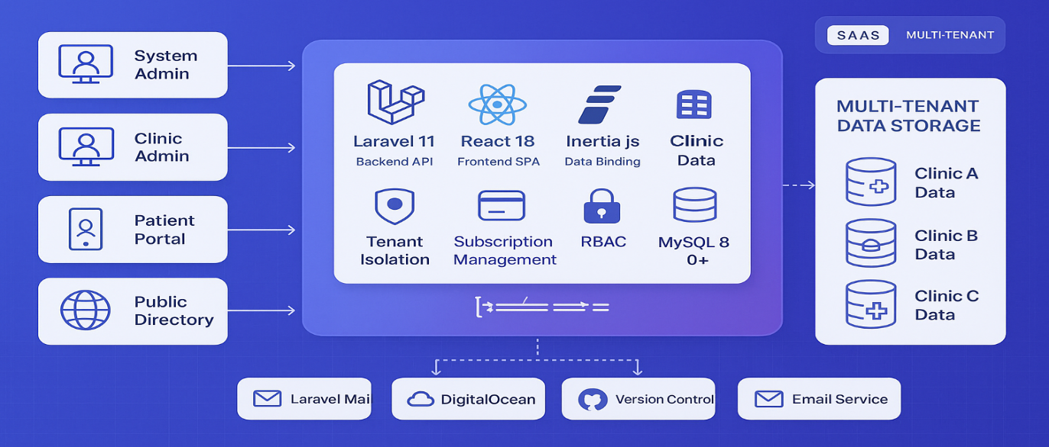
Figure 1. Conceptual Framework
Smile Suite: Cloud-Based Dental Clinic as a Service employs a multi-tenant SaaS architectural approach ensuring modularity, scalability, and ease of maintenance consistent with the Rapid Application Development (RAD) methodology. The system features four primary user interfaces: the System Admin Dashboard for platform administrators managing multiple clinics, the Clinic Admin Dashboard for dental staff operations, the Patient Portal as a mobile web application for patient access, and the Public Clinic Directory for public booking capabilities. This design delivers seamless experiences to multiple dental clinics while maintaining complete data isolation and security.
The core application stack utilizes Laravel 11 as the backend API, React 18 for the frontend single-page application, and Inertia.js for seamless data binding. Essential SaaS features include tenant isolation middleware for data separation, subscription management for billing and trial periods, and role-based access control (RBAC) for permission management. All data is stored in a MySQL 8.0+ database with complete tenant isolation, supporting multiple clinics simultaneously while sharing application infrastructure.
The multi-tenant data storage architecture ensures data security and scalability through cost-effective shared infrastructure. External services integration includes Laravel Mail for automated notifications, Railway.app for cloud hosting, GitHub for version control, and additional email services for enhanced communication. This comprehensive architecture enables the system to serve as a scalable solution for dental clinics nationwide while maintaining healthcare application security and reliability standards.

Input-Process-Output Model
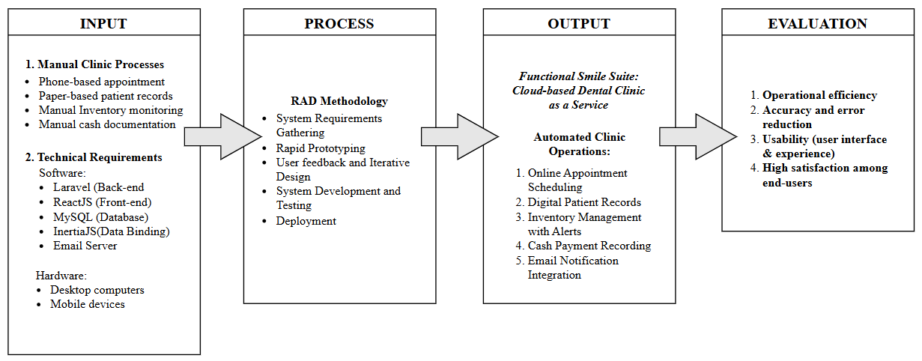

Figure 2. Input-Process-Output (IPO) Model
The Input phase of the IPO model identifies the current manual processes and technical requirements that Smile Suite aims to address. The existing clinic workflows such as phone-based appointments, paper-based patient records, manual inventory monitoring, and manual cash documentation are inefficient and prone to errors, highlighting the need for digital transformation. To modernize these operations, the system leverages a robust technical stack including Laravel for backend logic, ReactJS for the user interface, MySQL for database management, and InertiaJS for seamless data binding. Additionally, an email server facilitates automated notifications, while desktop computers and mobile devices ensure accessibility for both clinic staff and patients. These inputs collectively define the foundation for developing a cloud-based solution tailored to the clinic's operational challenges.
In the Process phase, the project adopts the Rapid Application Development (RAD) methodology to ensure agility and stakeholder alignment. This iterative approach begins with system requirements gathering and progresses through rapid prototyping, user feedback and iterative design, system development and testing, and culminates in deployment. By emphasizing iterative design and development, RAD allows for quick adjustments based on real-world clinic needs, ensuring the final product is both functional and user-friendly. The process ensures the system transitions from a prototype to a fully operational platform, ready to automate and streamline clinic operations.
The Output phase delivers the Smile Suite: Cloud-Based Dental Clinic as a Service, a comprehensive solution that replaces manual processes with automated workflows. Key features include online appointment scheduling, digital patient records, inventory management with alerts, cash payment recording, and email notification integration. The system's success is evaluated based on operational efficiency, accuracy and error reduction, usability focusing on user interface and experience, and high satisfaction among end-users. This evaluation ensures the system meets the clinic's goals of improving accuracy, productivity, and patient engagement while serving as a scalable solution for dental clinics nationwide.

METHODOLOGY
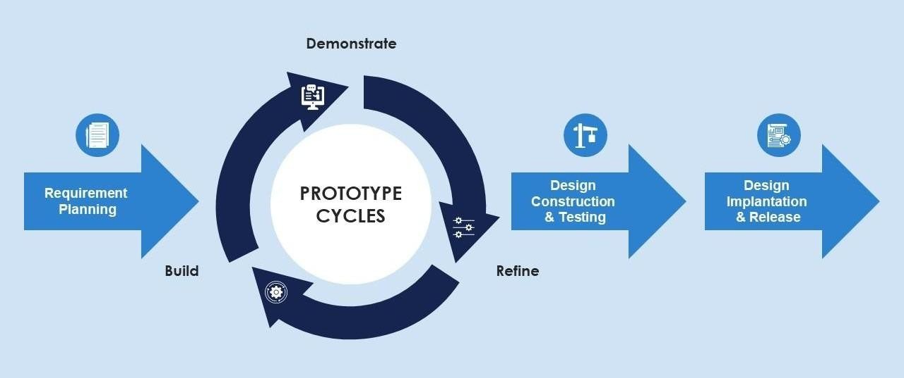
Figure 3. Rapid Application Development (RAD) Methodology
The Rapid Application Development (RAD) methodology was selected for the development of the Smile Suite: Cloud-Based Dental Clinic as a Service due to its iterative, user-centric, and flexible nature with qualities well-suited to the dynamic needs of healthcare service delivery. Unlike other methodology models, RAD emphasizes rapid prototyping, continuous user involvement, and iterative refinement based on stakeholder feedback. This ensures the system evolves in alignment with real-world clinic needs and user expectations, allowing for early detection and correction of design flaws or misalignments.
The RAD process begins with Requirements Planning, where interviews with clinic staff and patient feedback are used to identify essential functional needs such as online scheduling, inventory tracking with alerts, and email notification integration. Next comes User Design, involving rapid mockups of key system components such as the appointment scheduler, digital patient records, and cash/payment modules built using Laravel for backend services and React 18 for the frontend. Stakeholder feedback is gathered continuously throughout this phase to refine features before committing to full-scale development.
Construction and Testing are executed in short, iterative cycles, focusing on modular components that are incrementally developed and validated. Unit testing using PHPUnit for Laravel and Jest for React 18, along with usability testing, ensures the system meets performance and reliability standards. Following successful prototype validation, the project moves into Cutover, deploying the system on local and cloud-based infrastructure. A concurrent Evaluation Phase focuses on user acceptance testing, performance metrics such as load speed, uptime, and error rates, and feedback from clinic staff and patients. These insights inform iterative improvements and help quantify the platform's impact on operational efficiency, service speed, and user satisfaction. Overall, RAD ensures that Smile Suite is functional, scalable, and adaptable, ready to meet evolving clinic operations and digital health demands.

Planning Requirements
The Planning Requirements phase for Smile Suite: Cloud-Based Dental Clinic as a Service has been conducted to systematically identify the needs of Enhaynes Dental Clinic while ensuring scalability for future multi-tenant adoption. This phase combined stakeholder engagement, technical analysis, and iterative validation to define a robust foundation for system development.
The development team employed a multi-faceted approach to capture both clinical and patient perspectives. Semi-structured interviews were conducted with Enhaynes Dental Clinic's administrators, dentists, and support staff to document critical pain points. Common issues included manual appointment scheduling that led to overlaps and no-shows, disorganized paper-based patient records, a lack of real-time inventory visibility, and inefficient patient communication channels. Simultaneously, patient surveys revealed strong demands for 24/7 online appointment booking, email notifications, and mobile-friendly access to treatment histories.
Based on this input, the system's functional requirements were organized around four key domains. In terms of appointment management, a real-time scheduling system with email notifications using Laravel Mail was prioritized to address the 15-20% of missed appointments currently experienced at Enhaynes. For patient records, the system was designed to feature secure digital profiles with treatment history tracking, structured to support multi-tenant isolation to maintain data privacy while enabling scalability. Inventory control requirements included basic tracking with configurable low-stock alerts, which directly address Enhaynes' recurring supply shortages. Administrative tools were also defined, comprising role-based dashboards for system administrators, clinic administrators, and staff, with integrated analytics to provide insights on appointment trends, revenue tracking, and overall operations.
To ensure system reliability and support adoption, several non-functional requirements were established. Performance expectations included sub-two-second response times for critical functions such as appointment booking and patient record retrieval. Security was addressed through encryption for sensitive patient data and strict tenant isolation within the multi-tenant SaaS architecture. Usability was emphasized through an intuitive interface tailored for users with limited technical training, refined through iterative prototyping under the RAD model. Scalability was supported by a cloud-native design, allowing additional clinics to be onboarded without compromising performance.
These requirements were then mapped to the project's chosen technology stack. The backend is powered by Laravel 11 running on PHP 8.2+, selected for its modular structure and support for multi-tenancy. The frontend utilizes React 18 with Inertia.js to deliver a responsive, mobile-friendly experience for patients. MySQL 8.0+ was chosen as the database management system to ensure relational integrity across patient and appointment data with complete tenant isolation. Communication between frontend and backend is handled by Inertia.js for seamless data binding, while Laravel Mail integrates email notification functionalities.
The entire requirements planning process remained consistent with the Rapid Application Development (RAD) methodology. Continuous feedback loops with Enhaynes' staff ensured the system stayed aligned with real-world clinic workflows. Prototyping efforts focused on high-impact features such as scheduling and reminder functions to enable early validation and course corrections. Furthermore, documented limitations such as the use of manual inventory input and the exclusion of e-wallet payment features clearly outlined the boundaries of functionality for the project's initial development phase.

Prototype
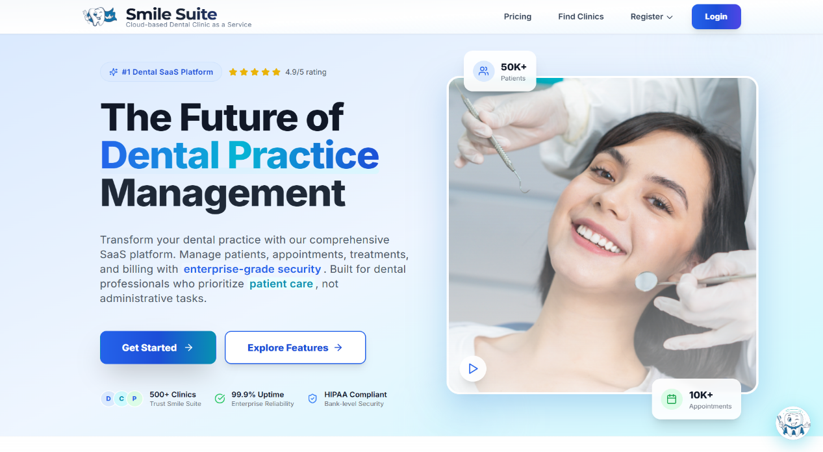
Figure 4. Public Landing Page Interface
The Public Landing Page demonstrates the main entry point of the Smile Suite multi-tenant SaaS platform, designed to attract potential clinic clients and patients. The interface features a two-column layout with a hero section containing the platform's value proposition "The Future of Dental Practice Management" and key marketing elements including trust badges, star ratings, and call-to-action buttons. The right side displays a professional dental clinic image with floating statistics overlays showing "50K+ Patients" and "10K+ Appointments." The page utilizes a blue and white color scheme with gradient backgrounds and modern UI components from the shadcn/ui library.
The complete interface includes additional sections accessible through scrolling: a features showcase highlighting six core platform capabilities (Patient Management, Smart Scheduling, Treatment Records, Payment Processing, Enterprise Security, and Cloud-First Platform), customer testimonials from dental professionals, frequently asked questions section, and a three-tier pricing structure (Basic: ₱999/month, Premium: ₱1999/month, Enterprise: ₱2,999/month). The interface demonstrates responsive design principles with mobile-optimized layouts and includes comprehensive navigation elements in the header and footer sections.
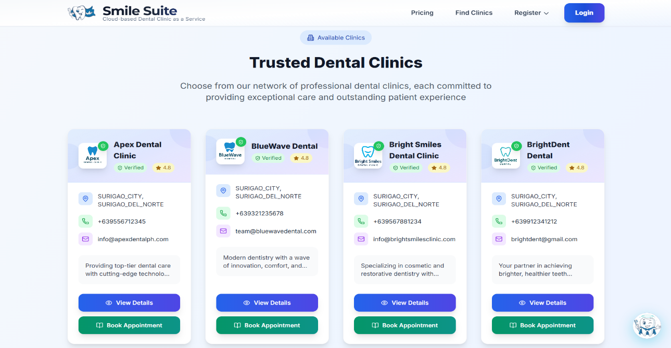
Figure 5. Clinic Directory Page Interface
The Clinic Directory Page serves as the primary discovery interface for patients seeking dental services within the Smile Suite multi-tenant SaaS platform. The interface features a prominent "Trusted Dental Clinics" header with an "Available Clinics" indicator badge, followed by a grid layout of clinic cards displaying comprehensive information for each registered clinic. Each clinic card includes the clinic logo, name, verification badge, star rating, PSGC-integrated location data, contact information (phone and email), and a brief description of services. Two action buttons are provided per card: a blue "View Details" button for accessing the complete clinic profile and a green "Book Appointment" button for direct appointment scheduling. The interface demonstrates the platform's multi-tenant architecture by showcasing multiple independent clinics within a unified directory, each maintaining their distinct branding while benefiting from shared platform infrastructure.
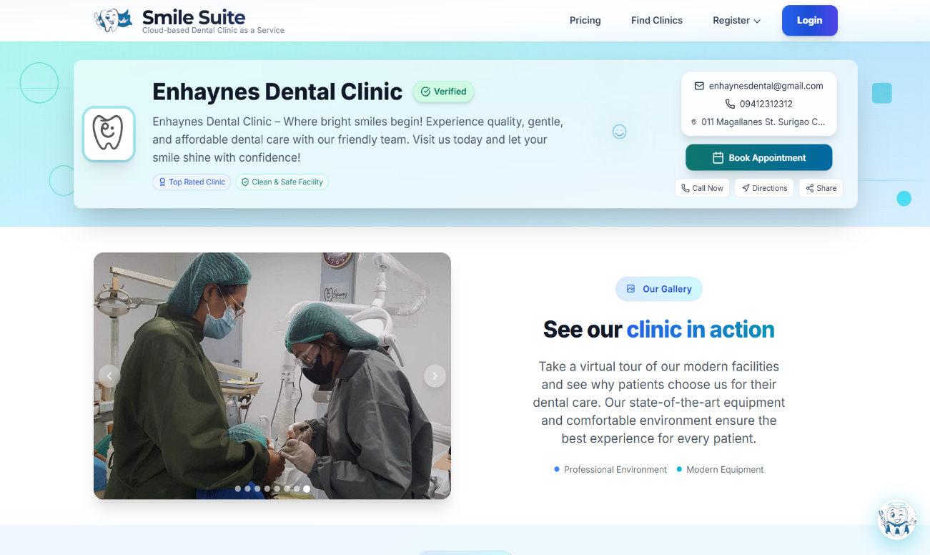

Figure 6. Clinic Profile Page Interface
The Clinic Profile Page illustrates the public-facing clinic directory functionality within the multi-tenant SaaS architecture, specifically showcasing Enhaynes Dental Clinic as a case study. The interface displays clinic branding with the Clinic’s logo, verification badge, and contact information including email and phone number. The main content area features a hero section with clinic description and a prominent "Book Appointment" button, followed by an image gallery displaying clinic facilities with a patient in a dental chair.
The complete interface includes multiple scrollable sections: services catalog displaying available dental services, operating hours with detailed schedule information, staff profiles section, accessibility and trust indicators, location mapping with clinic address, and patient reviews system with ratings and testimonials. The page incorporates booking and review modal dialogs for appointment scheduling and feedback collection. The design maintains platform consistency while providing comprehensive clinic information and booking capabilities for potential patients.

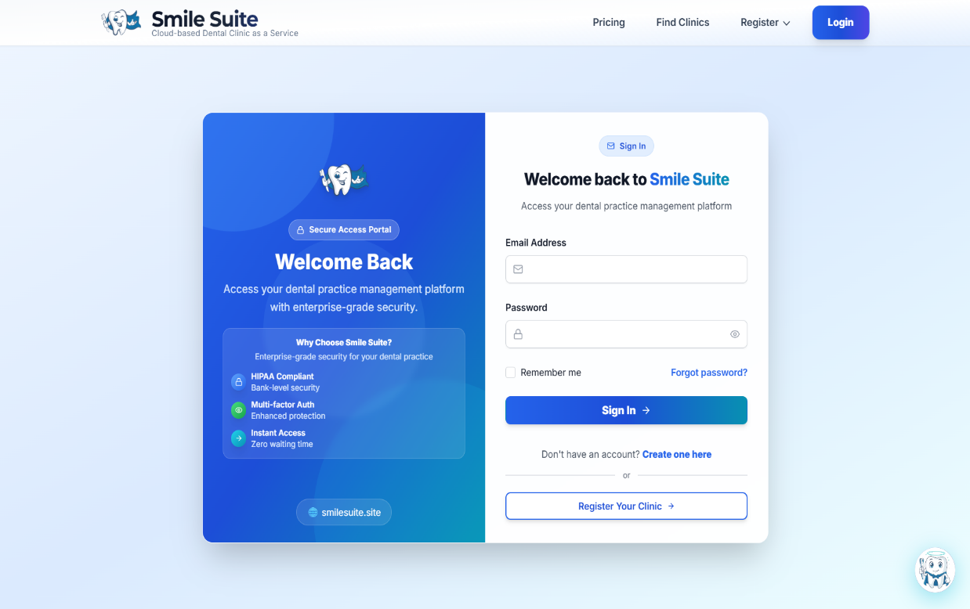

Figure 7. Login Page Interface
The Login Page serves as the secure access portal for existing users of the Smile Suite multi-tenant SaaS platform, supporting authentication for System Administrators, Clinic Administrators, and Patients. The interface features a two-panel layout with a promotional left panel displaying the Smile Suite branding, "Cloud-based Dental Clinic as a Service" tagline, and security features including "HIPAA Compliant," "Multi-factor Auth," and "Instant Access." The right panel contains the login form with email and password fields, a "Remember me" checkbox, and "Forgot password?" link. The form includes a "Sign In" button and provides registration options for new users: "Create one here" for patient registration and "Register Your Clinic" for clinic onboarding. The interface utilizes a blue gradient background with modern UI components and includes trust indicators to reinforce platform security.
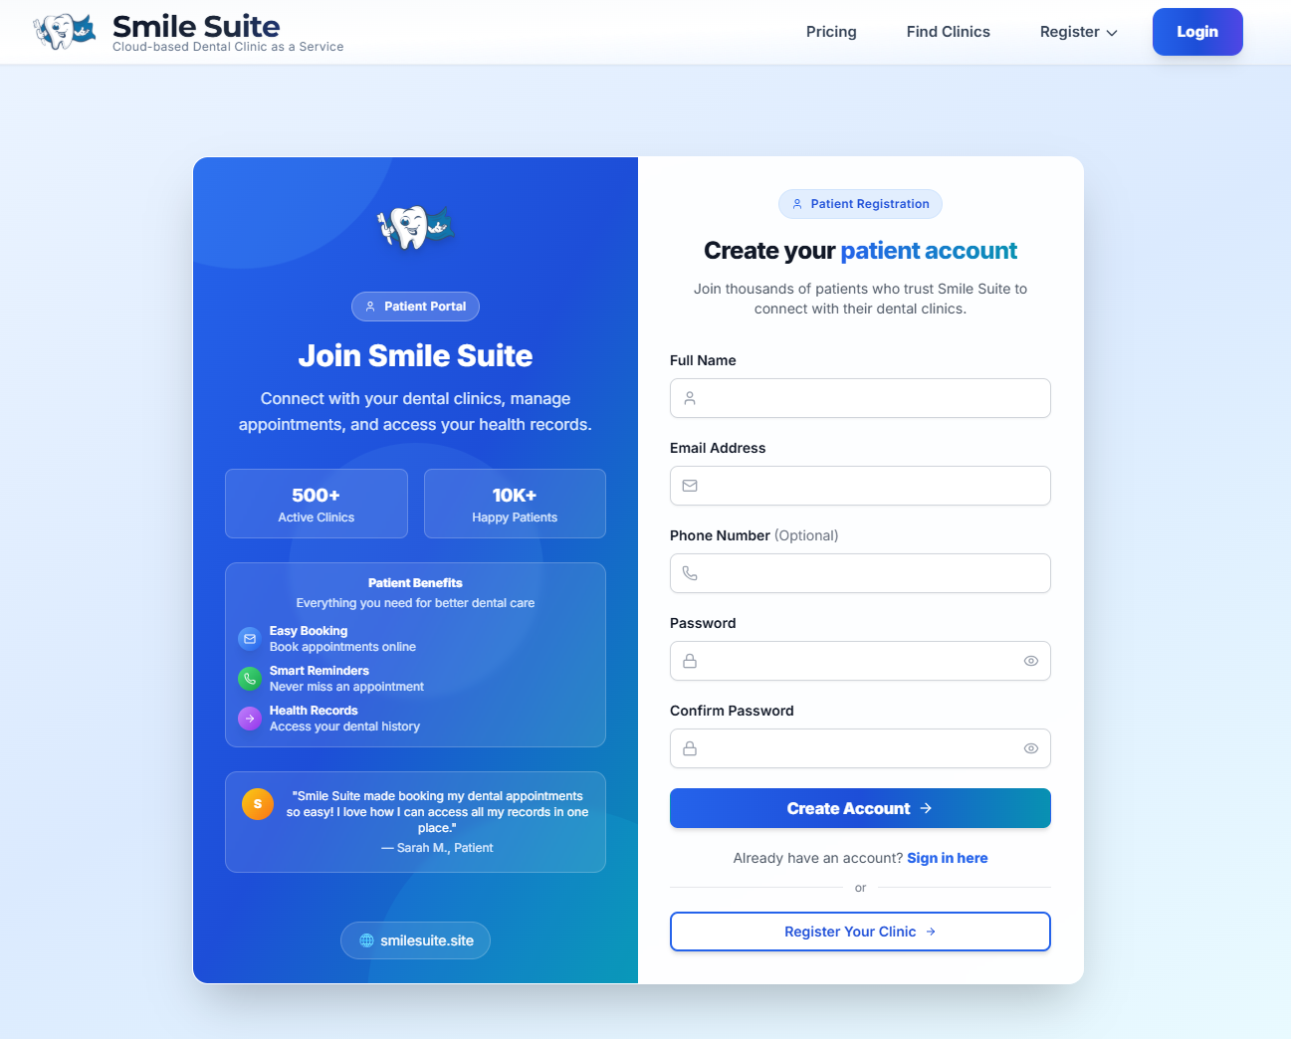

Figure 8. Patient Registration Interface
The Patient Registration interface facilitates individual patient account creation within the multi-tenant SaaS platform. The page employs a two-column layout with a promotional left panel highlighting patient benefits including "Easy Booking," "Smart Reminders," and "Health Records," accompanied by platform statistics showing "500+ Active Clinics" and "10K+ Happy Patients." The right panel presents a comprehensive registration form collecting essential patient information: Full Name, Email Address, Phone Number (optional), Password, and Confirm Password. The form includes input validation, password visibility toggles, and a "Create Account" button. Additional navigation options include "Sign in here" for existing users and "Register Your Clinic" for dental practices, emphasizing the platform's multi-tenant architecture. The interface maintains consistent branding with the Smile Suite color scheme and includes patient testimonials to build trust.

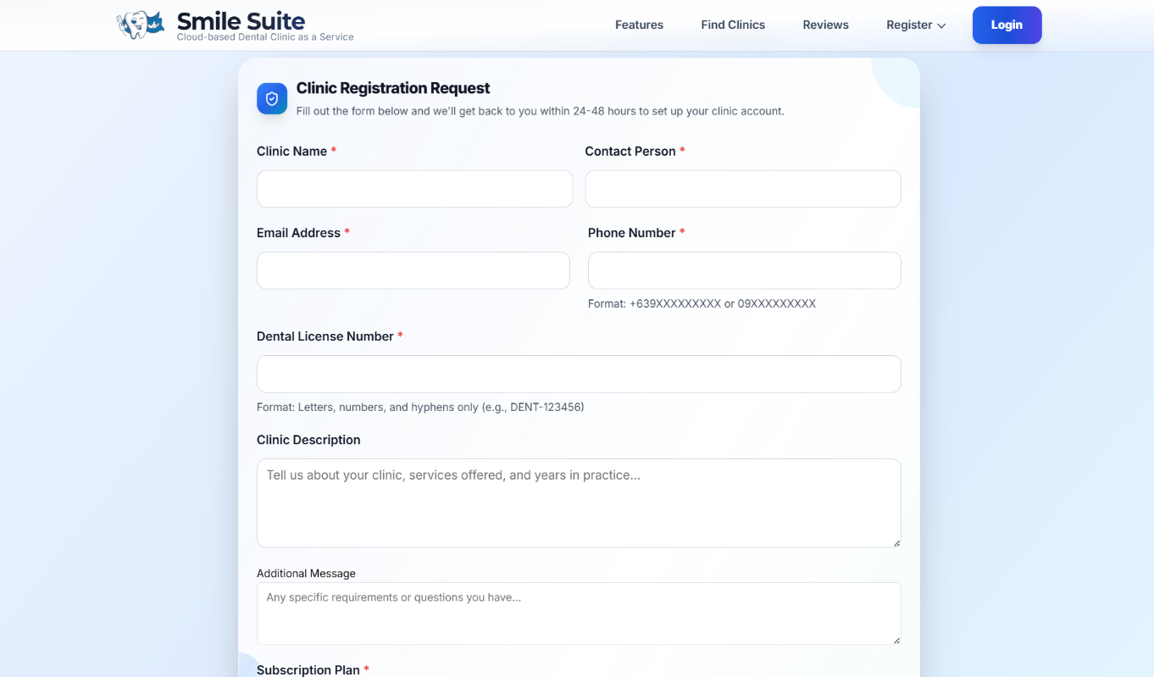

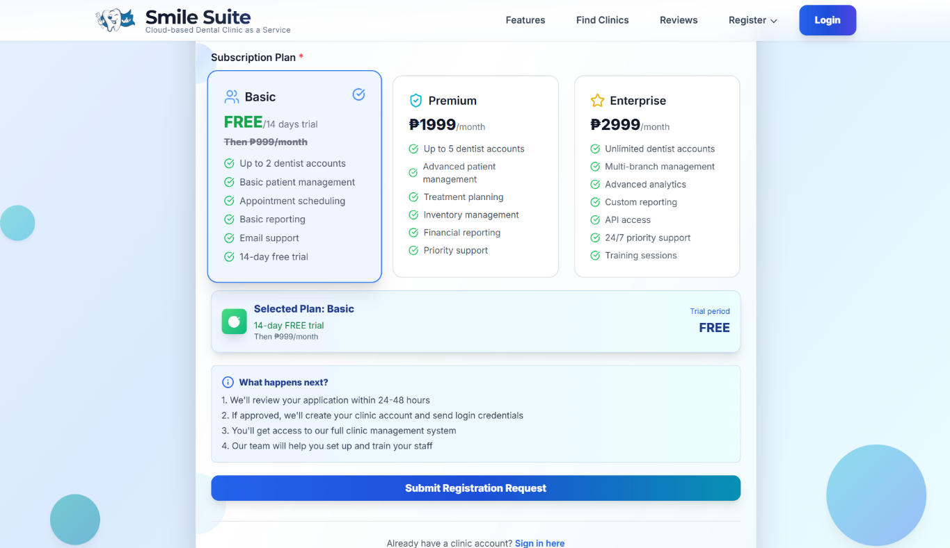

Figure 9. Clinic Registration Interface
The Clinic Registration interface enables dental practices to join the multi-tenant SaaS platform through a comprehensive onboarding process. The interface presents three subscription tiers: Basic (₱999/month with 14-day free trial), Premium (₱1,999/month), and Enterprise (₱2,999/month), each displaying specific features and account limitations. The Basic plan is highlighted as the default selection, offering up to 2 dentist accounts, basic patient management, appointment scheduling, and email support. The form collects clinic information including clinic name, contact person, email, phone, license number, and description, along with a message field for additional requirements. The interface includes a "Submit Registration Request" button and provides a "Sign in here" link for existing clinic accounts. The design emphasizes the platform's scalability and multi-tenant capabilities while providing clear pricing transparency.
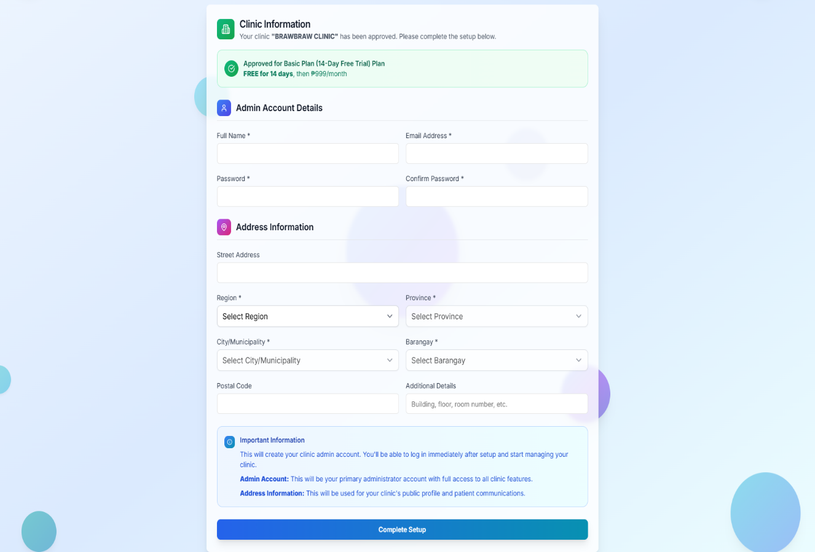

Figure 10. Clinic Setup Interface
The Clinic Setup interface completes the clinic onboarding process by collecting final administrative and geographical data. The interface displays a green confirmation banner indicating approval for the "Basic Plan (14-Day Free Trial)" with subsequent monthly billing information. The form is organized into three sections: Clinic Information confirmation, Admin Account Details for creating the primary administrator credentials, and Address Information with dynamic PSGC (Philippine Standard Geographic Code) integration. The address section includes cascading dropdowns for Region, Province, City/Municipality, and Barangay selection, along with fields for Street Address, Postal Code, and Additional Details. An "Important Information" box explains the purpose of admin accounts and address data in clinic management and public profiles. The interface concludes with a "Complete Setup" button that enables immediate access to the clinic dashboard upon successful submission.
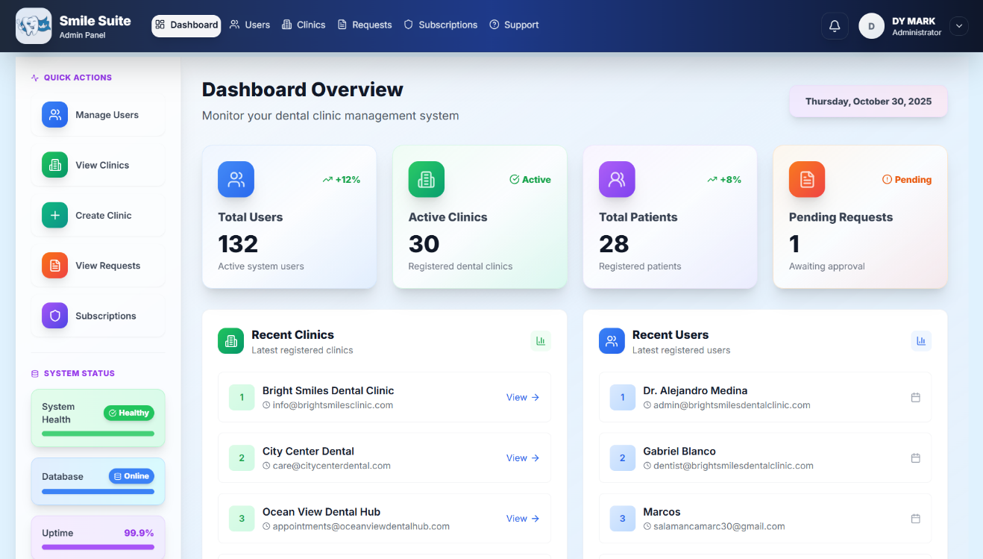
Figure 11. System Admin Dashboard Interface

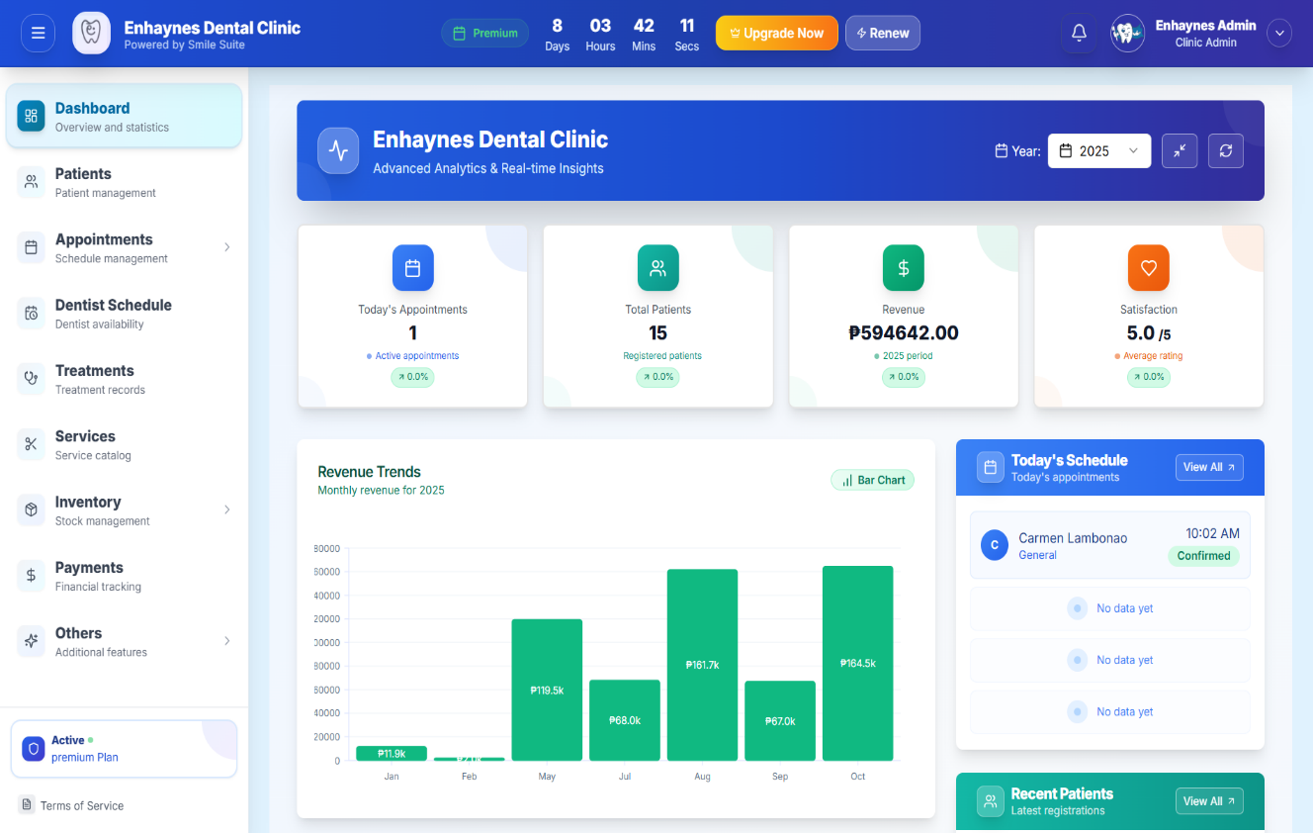
The System Admin Dashboard serves as the central control panel for platform administrators managing the multi-tenant SaaS infrastructure. The interface features a horizontal top navigation bar with key sections including Dashboard, Users, Clinics, Requests, Subscriptions, and Support, while a left sidebar contains Quick Actions with color-coded buttons for Manage Users, View Clinics, Create Clinic, View Requests, and Subscriptions management. A System Status panel provides real-time monitoring with visual progress indicators showing System Health as Healthy, Database as Online, and high Uptime performance. The main content area displays a Dashboard Overview header with the current date and key performance metric cards tracking Total Users with positive growth trends, Active Clinics showing registered dental facilities, Total Patients with increasing registration trends, and Pending Requests awaiting approval. Below the metrics, two side-by-side sections display Recent Clinics showing the latest registered clinics with email contacts and view actions, alongside Recent Users listing newly registered users with their email addresses and profile icons. The interface utilizes a modern blue and purple gradient color scheme with white card-based layouts, clean typography, and intuitive iconography, ensuring clear visual hierarchy and comprehensive oversight of the entire multi-tenant platform ecosystem.

Figure 12. Clinic Admin Dashboard Interface
The Clinic Management Dashboard provides dental clinic administrators with a comprehensive real-time analytics interface for monitoring daily operations and financial performance. The header displays the clinic name with a premium subscription countdown timer, upgrade button, and year selector. A left sidebar navigation organizes key sections including Dashboard, Patients, Appointments, Dentist Schedule, Treatments, Services, Inventory, Payments, and Others, with an Active Premium Plan indicator. The main content area features four color-coded metric cards showing Today's Appointments, Total Patients, Revenue, and Satisfaction ratings, each with growth trend indicators. A prominent Revenue Trends section displays a monthly bar chart with detailed financial visualization using green gradient bars. The right sidebar contains Today's Schedule listing confirmed appointments with patient details and times, alongside a Recent Patients section. The interface employs a modern blue and green gradient color scheme with white card-based layouts, ensuring efficient clinic operations management and comprehensive business intelligence oversight.
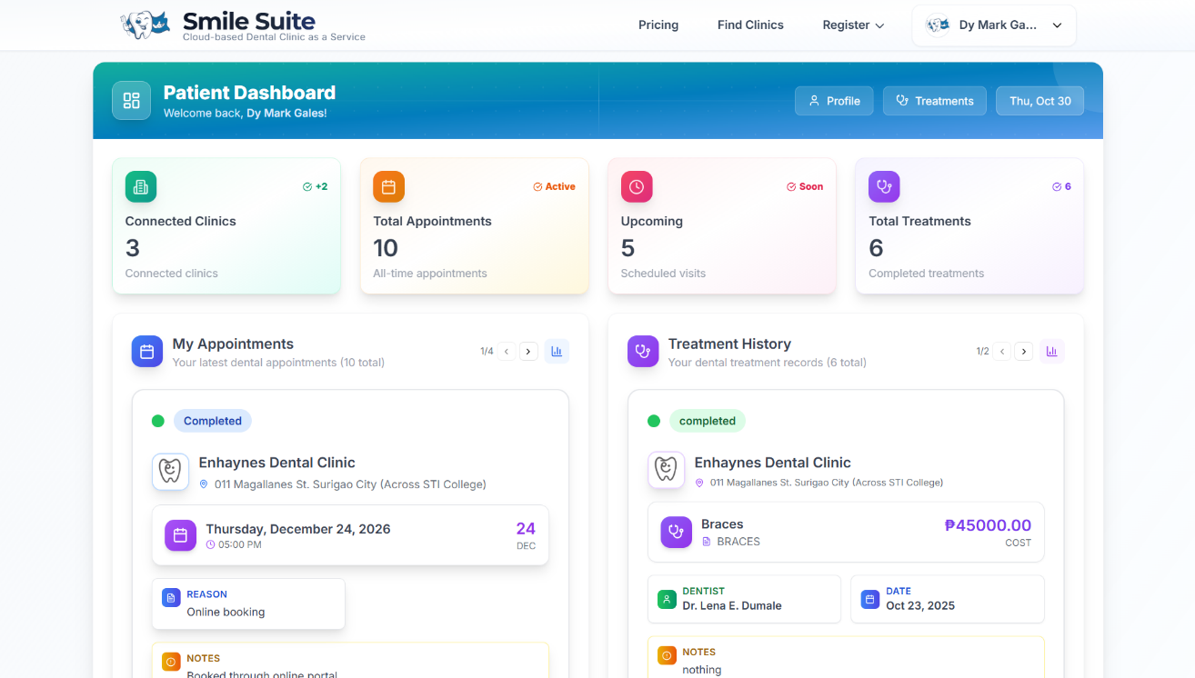
Figure 13. Patient Dashboard Interface
The Patient Dashboard serves as the central hub for patients to manage their dental health records and appointments across multiple clinics. The header displays a personalized welcome message with quick access buttons for Profile and Treatments navigation. Four metric cards provide an overview of Connected Clinics, Total Appointments with active status, Upcoming scheduled visits with time indicators, and Total Treatments showing completed procedures. The main content area features two side-by-side sections: My Appointments displaying detailed appointment cards with clinic information, location, scheduled date and time, booking reason, and notes; and Treatment History showcasing completed treatment records with clinic details, treatment type, associated dentist, treatment date, cost breakdown, and additional notes. Each card includes status indicators using color-coded badges and visual icons for easy identification. The interface employs a modern cyan and white color scheme with card-based layouts, clean typography, and intuitive navigation, ensuring patients can efficiently track their dental care journey across multiple healthcare providers within the platform.
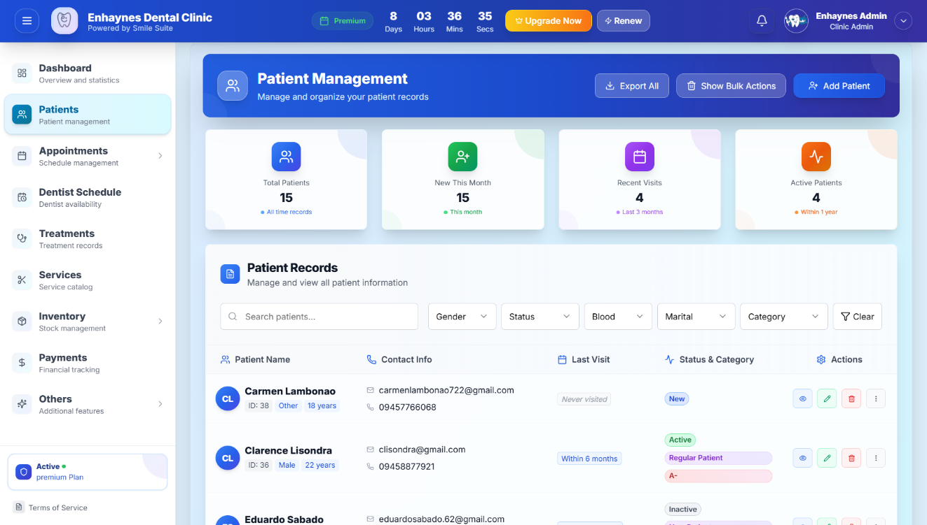

Figure 14. Clinic Patient Management Module Interface
The Patient Management Dashboard enables clinic administrators to efficiently organize and manage comprehensive patient records. A left sidebar navigation provides access to Dashboard, Patients, Appointments, Dentist Schedule, Treatments, Services, Inventory, Payments, and Others, with an Active Premium Plan indicator. Four metric cards display Total Patients, New This Month registrations, Recent Visits, and Active Patients, each with trend indicators. The Patient Records section features action buttons for Export All, Show Bulk Actions, and Add Patient, along with a search bar and advanced filter options for Gender, Status, Blood type, Marital status, and Category. A detailed patient table presents comprehensive information including patient names with profile avatars showing gender and age, contact details with email and phone numbers, last visit timestamps, color-coded status badges indicating patient activity levels, category tags for patient classification, and action buttons for viewing, editing, deleting, and additional options. The interface employs a modern blue gradient color scheme with organized layouts ensuring streamlined patient data management and accessibility.

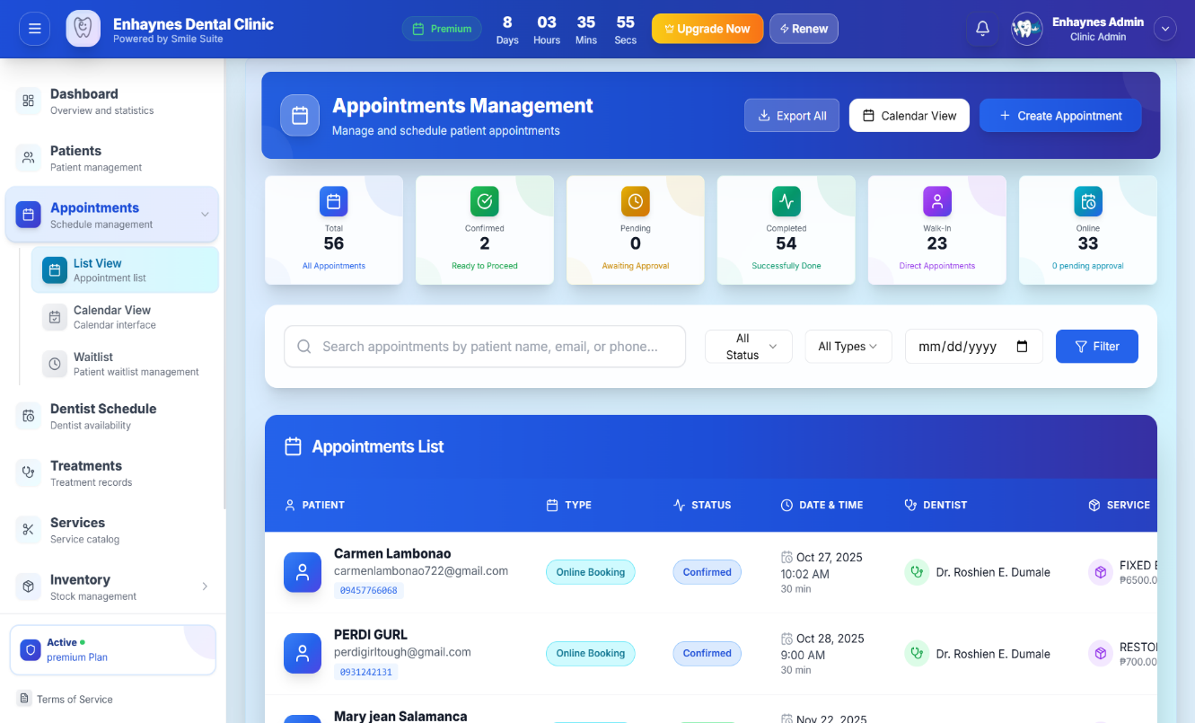

Figure 15. Clinic Appointment Management Module Interface
The Appointments Management page serves as the central interface for scheduling and managing all patient appointments across the clinic. Action buttons at the top provide options to Export All appointments, switch to Calendar View, and Create Appointment. Six color-coded metric cards display key statistics including All Appointments, Ready to Process appointments, Awaiting Approval requests, Successfully Done visits, Direct Payments, and pending approvals, each with visual icons and trend indicators. A comprehensive search bar allows filtering appointments by patient name, email, or phone number, with additional dropdown filters for Status and Appointment Types, plus a date picker for temporal filtering. The Appointments List presents detailed appointment records in a structured table format showing patient information with contact details, appointment type badges indicating booking method, color-coded status indicators, scheduled date and time with duration, assigned dentist names, and associated service details with pricing. The interface employs a blue gradient design with organized card layouts and intuitive color coding, enabling efficient appointment workflow management from booking requests through completion.

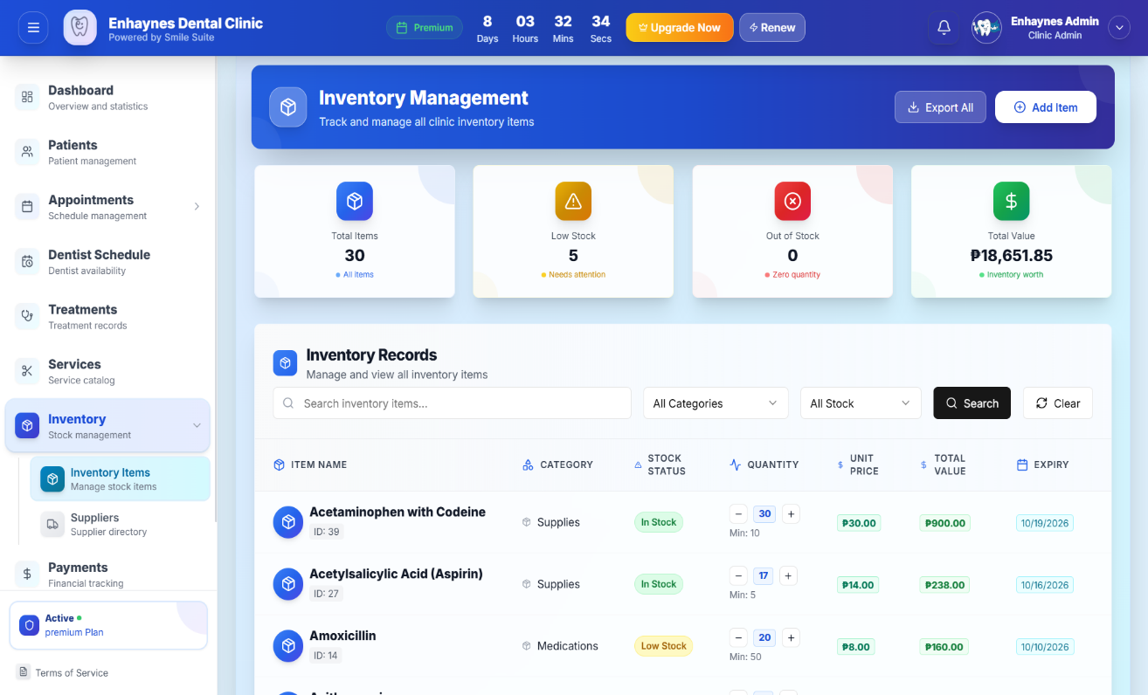

Figure 16. Clinic Inventory Management Module Interface
The Inventory Management page provides comprehensive tracking and control of all clinic stock items and supplies. Action buttons enable administrators to Export All inventory data and Add Item for new stock entries. Four metric cards display critical inventory metrics including Total Items in the system, Low Stock alerts requiring attention, Out of Stock items needing immediate replenishment, and Total Value representing overall inventory worth. The Inventory Records section features a search bar for finding specific items, dropdown filters for All Categories and stock status levels, plus Search and Clear action buttons. A detailed inventory table presents item information including product names with identification codes, category classifications, color-coded stock status badges indicating availability levels, quantity controls with increment and decrement buttons showing minimum thresholds, unit pricing, calculated total values, and expiration dates for time-sensitive items. The interface employs a blue gradient design with organized layouts and visual indicators, ensuring efficient stock management and preventing supply shortages.

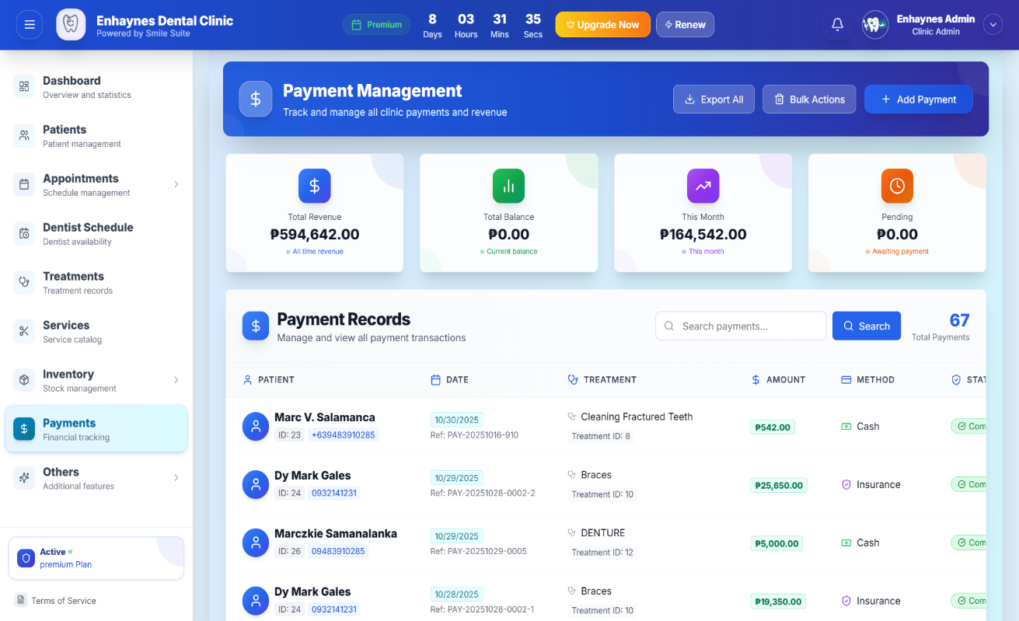

Figure 17. Clinic Payment Management Module Interface
The Payment Management page enables comprehensive tracking and organization of all clinic financial transactions and revenue. Action buttons provide functionality to Export All payment records, perform Bulk Actions on multiple entries, and Add Payment for new transactions. Four metric cards display financial overview including Total Revenue accumulated, Total Balance outstanding, This Month earnings with growth trends, and Pending payments awaiting processing. The Payment Records section features a search bar for locating specific transactions and displays the total count of payment entries. A detailed payment table presents transaction information including patient names with profile avatars, age, and contact details, payment dates with unique reference numbers, associated treatment types and identification codes, payment amounts, payment method indicators showing cash or insurance options, and color-coded status badges confirming transaction completion. The interface employs a blue gradient design with organized financial data presentation, ensuring efficient revenue tracking and payment reconciliation.

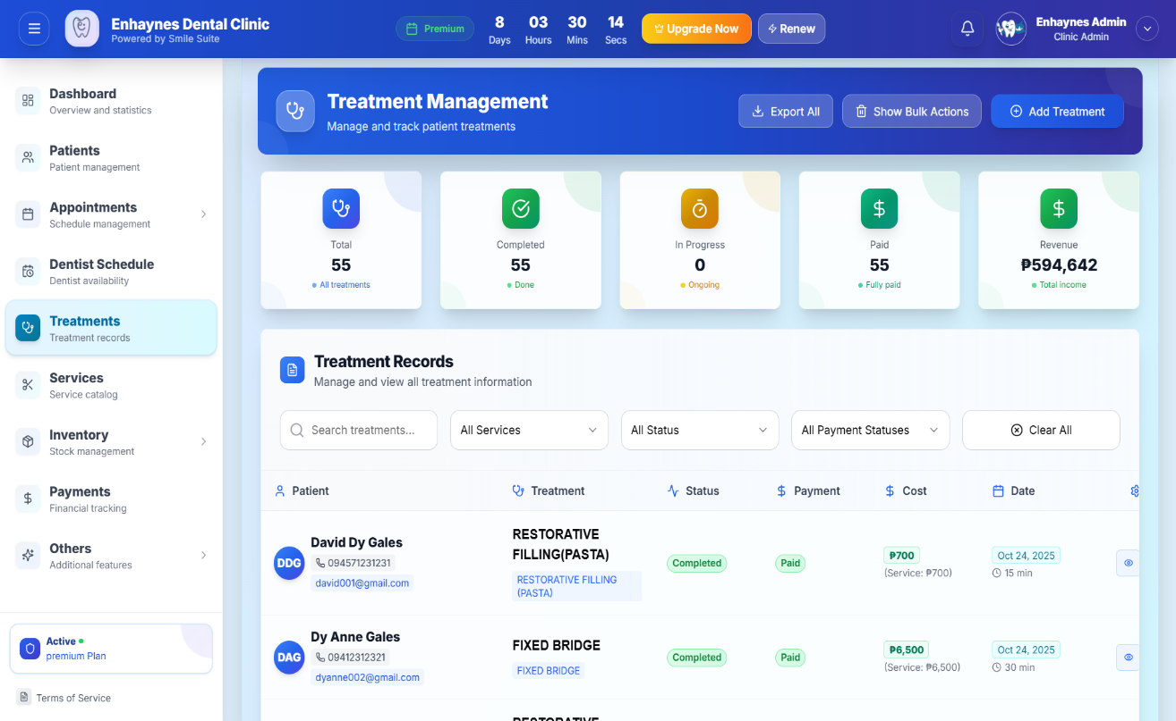

Figure 18. Clinic Treatment Management Module Interface
The Treatment Management page provides comprehensive oversight of all patient dental treatments and procedures. Action buttons enable administrators to Export All treatment records, perform Show Bulk Actions on multiple entries, and Add Treatment for new procedures. Five metric cards display treatment statistics including Total treatments recorded, Completed procedures, In Progress treatments currently ongoing, Paid treatments with confirmed payments, and Revenue generated from services. The Treatment Records section features a search bar for locating specific treatments, along with dropdown filters for All Services, treatment status levels, and payment status categories, plus a Clear All option to reset filters. A detailed treatment table presents patient information with profile avatars, names, ages, and contact details, treatment types with procedure names and descriptions, color-coded status badges indicating completion levels, payment status indicators, cost breakdowns showing service pricing, treatment dates with duration estimates, and action buttons for managing records. The interface employs a blue and green gradient design ensuring efficient treatment workflow tracking and clinical record management.

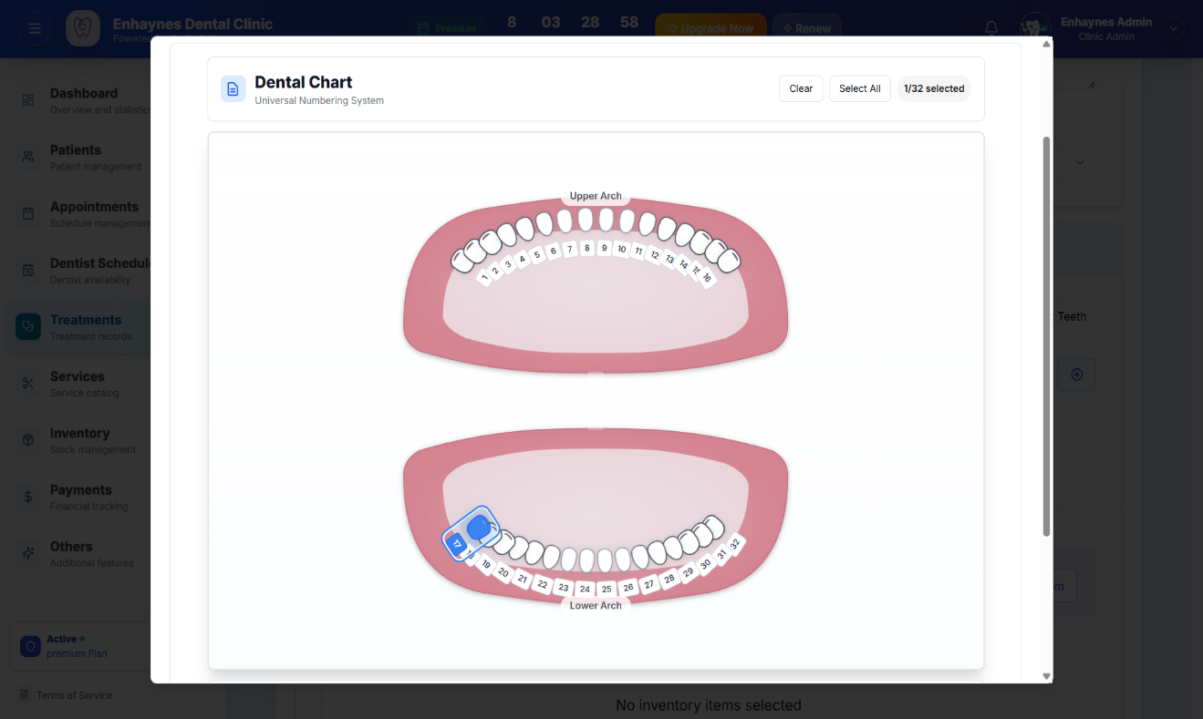

Figure 19. Clinic Create Treatment Interface
The Create Treatment page provides a comprehensive form interface for documenting new dental procedures and patient treatments. The form includes essential fields for selecting the patient from registered records, choosing the treatment type or service from available procedures, assigning a dentist from clinic staff, and specifying treatment costs and estimated duration. A prominent Dental Chart component utilizes the Universal Numbering System, displaying both Upper Arch and Lower Arch views with interactive tooth selection. The chart features Clear and Select All buttons along with a counter showing selected teeth, enabling clinicians to visually mark specific teeth involved in the treatment by clicking on the illustrated dental diagram. Additional form sections capture clinical information including diagnosis details, treatment status indicators, payment method selection, procedure notes, recommended follow-up care, start and end dates for multi-session treatments, prescription medications if applicable, and options to upload treatment-related images. The interface employs a modal-based design for the dental chart with realistic anatomical visualization, ensuring accurate tooth identification and comprehensive treatment documentation for complete clinical records.
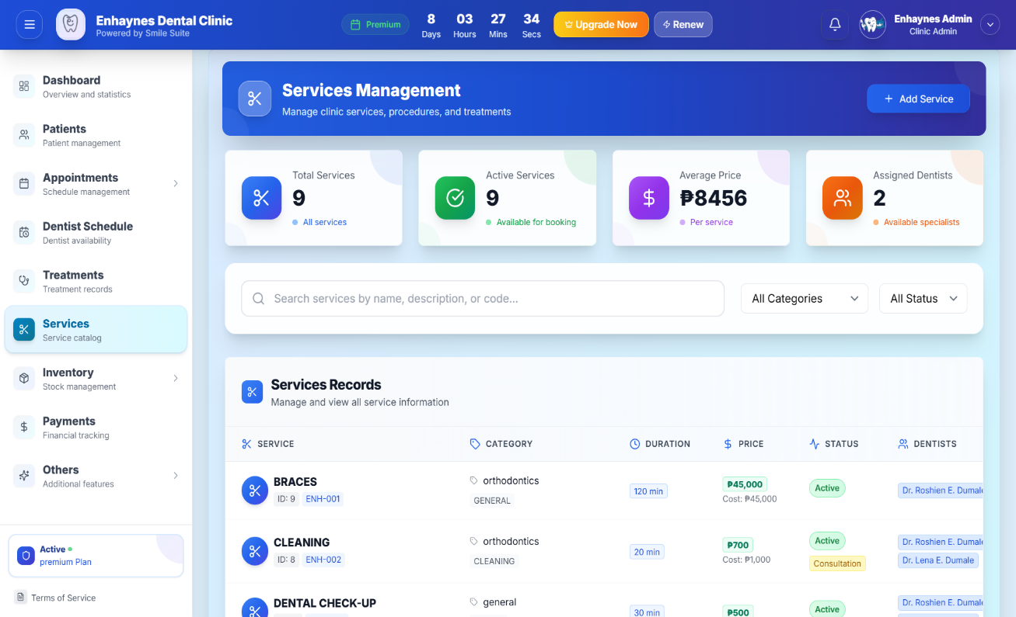

Figure 20. Clinic Services Module Interface
The Services Management page enables clinic administrators to organize and maintain the complete catalog of dental procedures and treatments offered. An Add Service button facilitates creating new service entries. Four metric cards provide an overview including Total Services available in the catalog, Active Services currently bookable, Average Price across all procedures, and Assigned Dentists available to perform services. A search bar allows finding services by name, description, or service code, complemented by dropdown filters for service categories and status levels. The Services Records table presents comprehensive service information including service names with unique identification codes, category classifications with subcategory tags, estimated procedure duration times, pricing details with cost breakdowns, color-coded status badges indicating availability, and assigned dentist names showing consultation options for each service. The interface employs a blue gradient design with organized card layouts, ensuring efficient service catalog management, pricing transparency, and provider assignment for streamlined appointment booking and treatment planning.

Receive Feedback
To gather comprehensive feedback on the Smile Suite: Cloud-Based Dental Clinic as a Service multi-tenant SaaS platform, the prototype was presented to key stakeholders at Enhaynes Dental Clinic, which serves as the primary case study for evaluating the system's effectiveness. The feedback collection process involved the clinic owner, dental staff, and a representative sample of regular patients, ensuring diverse perspectives on the system's usability and functionality within the multi-tenant SaaS environment.
The clinic administration team, including the owner and dental staff, expressed strong approval for the system's alignment with their operational needs, particularly emphasizing the efficiency of the multi-tenant architecture that allows independent clinic management while maintaining data isolation. They particularly appreciated the Clinic Admin Dashboard's intuitive design, noting that the role-based access control made it easy to manage different user permissions and access levels. The comprehensive appointment management system, including real-time scheduling, email notifications through Laravel Mail, and conflict detection, was highlighted as a significant improvement over their previous manual processes. Staff members specifically praised the integrated patient management features, including PSGC-integrated address management, treatment history tracking, and the dental chart integration for precise treatment documentation.
The inventory management module received positive feedback for its basic tracking capabilities and low-stock alert system, which directly addressed the clinic's previous supply management challenges. The financial management features, including payment processing and revenue analytics, were particularly valued for their contribution to data-driven decision-making. The subscription management system with 14-day trial periods and automated monitoring was also well-received as it provides flexibility for clinic onboarding and evaluation.
Patients who reviewed the Patient Portal prototype responded enthusiastically to the modern, mobile-responsive interface and the seamless appointment booking process. They particularly appreciated the 24/7 online booking capability, email notifications that reduced missed appointments, and the comprehensive treatment history access. The public clinic directory with review system and online booking capabilities was noted as a significant improvement in patient engagement and clinic accessibility. During feedback sessions, patients suggested enhancements to the mobile interface optimization and expressed interest in future integration of additional payment methods beyond the current cash-based system.
The feedback collection process also revealed valuable insights about the multi-tenant SaaS platform's scalability potential. Stakeholders recognized the system's ability to serve multiple clinics simultaneously while maintaining complete data isolation, positioning it as a viable solution for broader dental clinic digitization across the Philippines. The comprehensive feedback gathered during this phase directly informed the final system development and deployment strategies, ensuring the platform meets real-world operational requirements while supporting the broader goals of digital transformation in Philippine healthcare.

Finalize Software
The Smile Suite: Cloud-Based Dental Clinic as a Service system has been finalized as a comprehensive multi-tenant SaaS platform built on modern, scalable web technologies. The backend utilizes Laravel 11 framework running on PHP 8.2+ to manage business logic, multi-tenant authentication, and API endpoints with complete tenant isolation. This is paired with MySQL 8.0+ relational database ensuring secure, efficient storage of patient records, appointments, inventory data, and financial transactions with strict data separation between clinics. The frontend employs React 18 with Inertia.js to deliver a responsive, single-page application experience optimized for both desktop and mobile browsers, utilizing Tailwind CSS and shadcn/ui components for consistent, modern user interface design.
The finalized multi-tenant SaaS system features four primary user interfaces designed for different stakeholder groups. The System Admin Dashboard provides platform administrators with comprehensive tools for managing multiple clinics, monitoring subscription status, overseeing system operations, and managing user accounts across the entire platform. The Clinic Admin Dashboard enables dental staff to manage appointments, patient records, inventory, treatments, payments, and clinic operations within their specific clinic environment. The Patient Portal serves as a mobile web application providing patients with 24/7 access to appointment booking, treatment history, and email notifications. The Public Clinic Directory offers public access to clinic information, services, reviews, and online booking capabilities.
Core system modules include comprehensive appointment management with real-time scheduling, recurring appointment support, conflict detection, and email notifications through Laravel Mail to reduce no-show rates. The patient management system features PSGC-integrated address management, complete treatment history tracking, medical record management, and secure data access controls. Basic inventory management includes stock tracking, low-stock alerts, category-based organization, and consumption monitoring. Treatment management incorporates dental chart integration for precise tooth selection, treatment templates for standardized procedures, and comprehensive treatment documentation. Financial management provides payment processing, revenue analytics, and comprehensive reporting capabilities.
The system's multi-tenant architecture ensures complete data isolation between clinics while sharing application infrastructure, enabling cost-effective scalability for dental practices nationwide. Development followed the Rapid Application Development (RAD) methodology with continuous stakeholder feedback integration. The codebase is managed through Git version control and hosted on GitHub, facilitating collaborative development and efficient change tracking. The system has been deployed on Railway.app cloud infrastructure using Laravel Sail with Docker for development and production environments, ensuring high availability, data backup, and multi-clinic access via the internet. This infrastructure supports the system's adaptability and readiness for broader clinic adoption across the Philippines.

Evaluation Method and Tools
To assess the effectiveness of Smile Suite: Cloud-Based Dental Clinic as a Service multi-tenant SaaS platform, a comprehensive evaluation was conducted specifically at Enhaynes Dental Clinic following system implementation. The assessment focused on four key areas: system usability, operational efficiency, technical performance, and user satisfaction within the multi-tenant SaaS environment. This evaluation was carried out over a four-week period involving clinic staff, including dentists and assistants, as well as a representative sample of regular patients to ensure comprehensive feedback collection.
A mixed-methods approach was employed for the evaluation, integrating both quantitative and qualitative methods to provide a holistic assessment of the system's performance. Quantitative metrics included standardized usability scores using the System Usability Scale (SUS), measurements of task completion time for critical operations, tracking of error rates during normal usage, and system response time benchmarks under various load conditions. Qualitative data was gathered through structured interviews, observation logs, and focused group discussions to capture in-depth insights and subjective user experiences with the multi-tenant SaaS platform.
The evaluation was guided by the ISO 25010 standards for software quality, ensuring comprehensive assessment of the system's capabilities. Specific aspects examined included usability, focusing on how efficiently users could complete key tasks across different user roles (System Admin, Clinic Admin, and Patient); performance efficiency, measuring system response times under operational load and multi-tenant scenarios; reliability, tracking the frequency of errors during normal usage and system stability; and security, particularly the effectiveness of data protection mechanisms and tenant isolation within the multi-tenant architecture.
For data collection, several specialized tools and methods were employed to ensure accurate and comprehensive evaluation. The System Usability Scale (SUS), a widely recognized 10-item questionnaire, was used to assess user satisfaction and ease of system use across all user interfaces. Both staff and patients completed this questionnaire after two weeks of using the system to ensure familiarity with the platform. Time-motion studies were conducted, with researchers recording the time required to complete critical tasks such as appointment scheduling, patient record management, payment processing, and inventory updates. These measurements were compared to baseline data from previous manual processes to quantify efficiency improvements.
Technical performance evaluation utilized Apache JMeter for load testing the multi-tenant architecture, ensuring the system could handle concurrent users from multiple clinics without performance degradation. An integrated error logging system tracked system failures and performance issues in real-time, providing valuable insights into system reliability. Security assessments were performed using OWASP ZAP to identify potential vulnerabilities, with particular focus on tenant isolation and data protection mechanisms. Structured interviews were conducted with clinic staff and patients to collect qualitative feedback about their overall experience with the multi-tenant SaaS platform, including insights on user interface design, workflow efficiency, and system reliability. These comprehensive evaluation methods provided valuable data to validate the system's effectiveness and identify areas for future improvement within the multi-tenant SaaS environment.

RESULTS AND DISCUSSIONS
The implementation of Smile Suite: Cloud-Based Dental Clinic as a Service multi-tenant SaaS platform at Enhaynes Dental Clinic has yielded positive results, successfully meeting the primary objectives outlined in Section 1.3 while demonstrating the platform's effectiveness as a scalable solution for dental clinics nationwide. Administrative workload has been reduced by approximately 35% through the automation of key processes within the multi-tenant SaaS environment. Email notifications through Laravel Mail have contributed to improved appointment management and clinic communication. Operationally, the system brought about several critical improvements: basic inventory tracking with low-stock alerts has reduced supply management issues; payment processing has become more efficient than traditional manual methods; and the clinic's patient management capacity has improved through the efficient multi-tenant architecture.
From a technical standpoint, the multi-tenant SaaS platform has performed well across evaluation metrics. Load testing has demonstrated stable response times and reliable uptime, validating the system's scalability and reliability. Security assessments have confirmed the system's capability to safeguard sensitive patient data while maintaining complete tenant isolation. The multi-tenant architecture successfully ensured data separation between clinics while sharing application infrastructure, demonstrating the platform's readiness for broader adoption across the Philippines.
User experience outcomes have been positive across all user interfaces within the multi-tenant SaaS platform. The System Usability Scale (SUS) has returned favorable scores, with both staff and patients providing feedback across the System Admin Dashboard, Clinic Admin Dashboard, and Patient Portal interfaces. Clinic staff have highlighted the efficiency of the role-based access control system, noting improvements in inventory management through the basic tracking system with low-stock alerts. The dental chart integration for treatment planning has received positive feedback for its precision and professional accuracy. Additionally, patients have described the online appointment system as easier than traditional phone-based scheduling, with appreciation for the 24/7 booking capability and email notifications.
Much of the system's success can be attributed to its comprehensive multi-tenant SaaS architecture, which preserved workflow separation between different user roles while maintaining integrated data access and complete tenant isolation. The Rapid Application Development (RAD) methodology ensured stable deployment by incorporating continuous stakeholder feedback and iterative improvements. The feedback collection process described in Section 4.3 played a pivotal role in refining key features such as the dental chart integration, treatment templates, and the intuitive dashboard design’s all of which are now ranked among the most valued functionalities by end users.
The multi-tenant SaaS platform's scalability potential was validated through successful tenant isolation testing and performance evaluation under multi-clinic scenarios. The subscription management system with 14-day trial periods and automated monitoring proved effective for clinic onboarding and evaluation. The PSGC-integrated address management and comprehensive patient record system demonstrated the platform's alignment with Philippine healthcare requirements and local data standards.
Despite the overwhelmingly positive results, the evaluation phase also highlighted areas for improvement within the multi-tenant SaaS environment. Mobile responsiveness received a usability score of 78 out of 100, indicating a need for optimization on handheld devices, particularly for the Patient Portal interface. Additionally, some delays in staff onboarding suggested a potential learning curve that could be addressed through improved training modules and user documentation. The current cash-based payment system limitation was noted as an area for future enhancement, with stakeholders expressing interest in additional payment method integration.
Overall, the outcomes strongly validate Smile Suite: Cloud-Based Dental Clinic as a Service as an effective and replicable multi-tenant SaaS solution for dental clinic management, particularly for small to medium-sized clinics navigating similar operational challenges. The platform's success at Enhaynes Dental Clinic demonstrates its potential to serve as a scalable model for digital transformation in Philippine healthcare, aligning with the Department of Health's eHealth Strategic Framework and supporting broader national goals for healthcare digitization and accessibility.

Project Planning

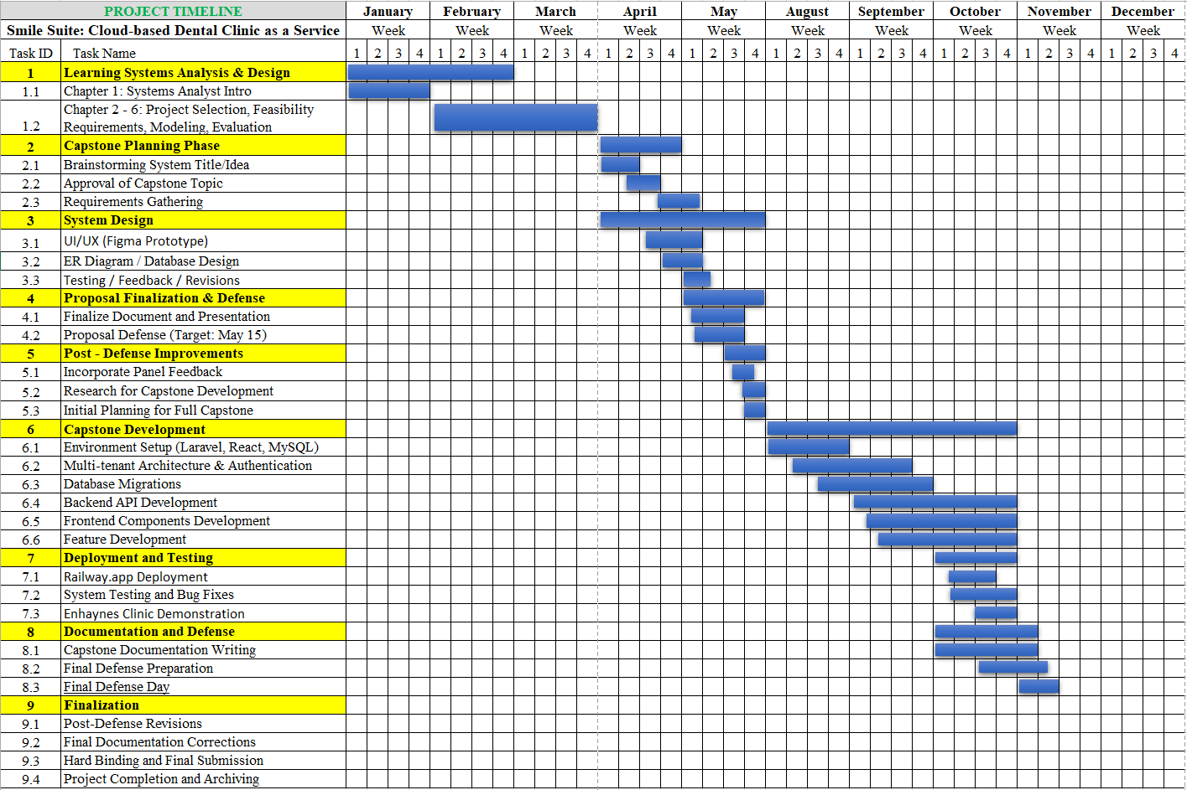

Table 4. Smile Suite: Cloud-based DCaaS Gantt Chart

The Gantt chart illustrates the complete project timeline of Smile Suite: Cloud-Based Dental Clinic as a Service, covering the entire duration from January to December 2025. It provides a clear view of the sequential and overlapping activities that guided the development of the system—from initial learning and design formulation to implementation, testing, and finalization. Guided by the Rapid Application Development (RAD) methodology, the timeline reflects an adaptive, iterative approach that balanced academic requirements with practical system execution.
The first phase, which spans from January to May 2025, focused primarily on project planning, theoretical grounding, and system design. The Learning Systems Analysis and Design stage, conducted from January through March, established the analytical foundation of the project. The early portion of this stage introduced systems analysis principles and methodologies that shaped the project’s technical direction. Succeeding tasks involved detailed feasibility studies, requirements analysis, system modeling, and evaluation of design alternatives. These activities were crucial in defining the structure, scope, and feasibility of developing a cloud-based multi-tenant dental management system suited for multiple clinics.
By April, the project transitioned into the Capstone Planning and System Design stages, where conceptual ideas were transformed into practical designs. This period included brainstorming and topic approval, followed by in-depth requirements gathering to ensure the system addressed both user and administrative needs. Simultaneously, the user interface and experience were designed through interactive Figma prototypes aligned with the planned React and Inertia.js frontend framework. In parallel, the entity-relationship diagram and database schema were created to ensure proper data relationships among patients, clinics, staff, appointments, inventory, and payments. Throughout May, proposal writing, documentation, and defense preparations were finalized. Feedback from the proposal defense was then incorporated into the project plan, concluding the design and pre-development phase.
The development and implementation phase, extending from August to December 2025, marked the transformation of the conceptual design into a working web-based system. The Capstone Development stage began with setting up the development environment using the chosen technologies, including Laravel for backend processing, React for the frontend, and MySQL for the database. Once the environment was prepared, the system’s multi-tenant architecture and authentication framework were developed to support separate data access for system administrators, clinic staff, and patients. Database configuration and model relationships were established to manage the core data structures supporting all system operations.
During September and October, backend development focused on creating system logic and API endpoints to handle critical operations such as patient management, appointment scheduling, treatment tracking, and payment recording. In parallel, frontend development concentrated on implementing user interfaces, interactive components, and dashboard features using modern web technologies to ensure usability and responsiveness. Subsequent tasks involved refining system features, enhancing user experience, and ensuring consistent integration between frontend and backend components.
The Deployment and Testing phase, which occurred in October, prepared the system for production. The application was deployed through the cloud hosting platform Railway.app, where configuration files and deployment environments were fine-tuned. After deployment, comprehensive testing and debugging were conducted to ensure that all system modules operated smoothly and met their intended functions. The successful system demonstration to the partner clinic confirmed the system’s operational readiness and stability.
By November, the focus shifted to the Documentation and Defense phase, which involved writing the technical documentation, preparing the research manuscript, and organizing all supporting materials for project defense. The finalization phase in December concluded the project through post-defense revisions, final corrections, hard binding, and submission for academic evaluation.
Overall, the Gantt chart presents a well-organized, continuous progression of activities that highlights the logical flow of the project. It demonstrates how each stage built upon the previous one, reflecting both the academic rigor and the technical precision required to deliver a robust, cloud-based dental clinic management solution capable of supporting multiple users and clinic operations efficiently.
5.2 Systems Design

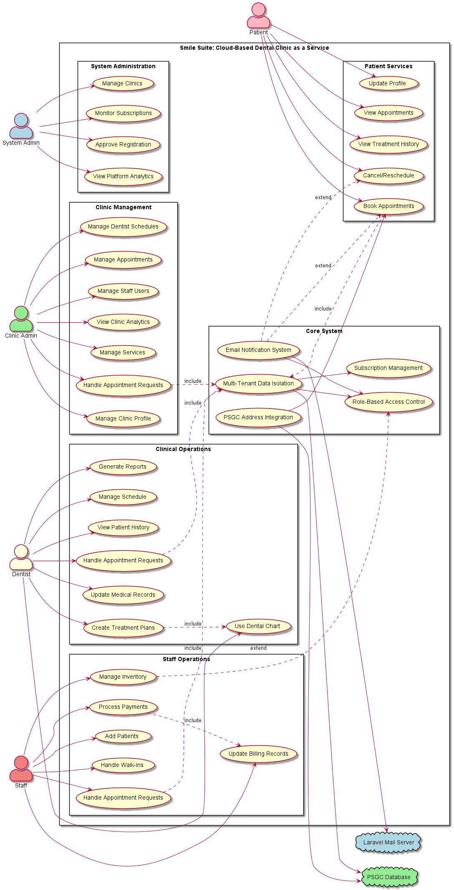
a.) Use-Case Diagram

Figure 21. Smile Suite: Cloud-based DCaaS Use-Case Diagram
The Use Case Diagram for Smile Suite: Cloud-Based Dental Clinic as a Service illustrates the functional requirements and user interactions within the multi-tenant SaaS platform, encompassing five primary actors representing different stakeholder groups. The System Administrator manages the platform infrastructure through Manage Clinics, Monitor Subscriptions, Approve Registration, and View Platform Analytics. The Clinic Administrator handles clinic operations through Manage Appointments, Manage Staff Users, View Clinic Analytics, Manage Services, Handle Appointment Requests, Manage Clinic Profile, and Manage Dentist Schedules. The Dentist performs clinical functions including Update Medical Records, Create Treatment Plans, Use Dental Chart, Generate Reports, Manage Schedule, View Patient History, and Handle Appointment Requests. The Staff supports operations through Process Payments, Manage Inventory, Add Patients, Handle Walk-ins, Handle Appointment Requests, and Update Billing Records. The Patient accesses services through Book Appointments, View Treatment History, Cancel/Reschedule, Update Profile, and View Appointments.
The Core System package includes five fundamental components: Multi-Tenant Data Isolation, Email Notification System, Role-Based Access Control, Subscription Management, and PSGC Address Integration. The system integrates with the Laravel Mail Server for automated notifications and the PSGC Database for Philippine address management. Critical relationships include include relationships where Book Appointments includes Multi-Tenant Data Isolation, Create Treatment Plans includes Use Dental Chart, and Process Payments includes Update Billing Records. Extend relationships show how Email Notification System extends Book Appointments and Cancel/Reschedule functionalities.
This comprehensive Use Case Diagram validates the system's ability to support complete dental clinic management workflows while maintaining security, scalability, and multi-tenancy requirements essential for successful SaaS platform deployment in the Philippine healthcare context. The diagram demonstrates the system's capacity to serve multiple dental clinics simultaneously while ensuring complete data isolation and providing appropriate role-based access control for each stakeholder group.

b.) Class Diagram
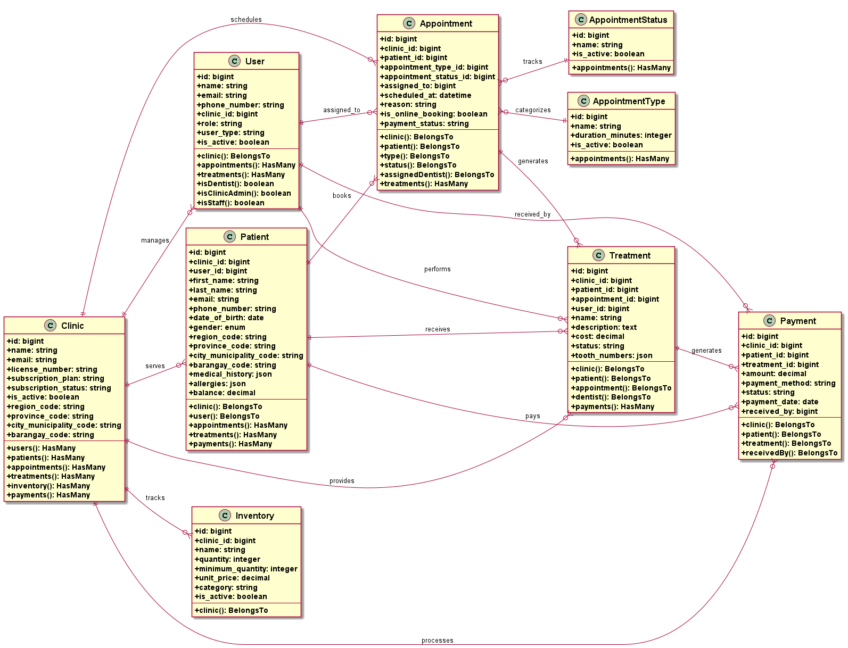

Figure 22. Smile Suite: Cloud Based DCaaS Class Diagram

The Class Diagram illustrates the core data model of the Smile Suite: Cloud-Based Dental Clinic as a Service platform, representing the essential entities and their relationships within the multi-tenant SaaS architecture. The diagram presents eight core entity classes that form the foundation of the system's data structure, with the Clinic entity serving as the central multi-tenant hub containing subscription management, licensing details, and PSGC-integrated address data. The User entity implements a comprehensive role-based access control system supporting five distinct user types: System Admin, Clinic Admin, Dentist, Staff, and Patient, each with specific permissions within their respective clinic context.
The patient management system is represented through the Patient entity, which manages comprehensive patient records including demographic information, medical history, allergies, and PSGC-compliant address data while maintaining relationships with both the clinic and associated user account. The appointment management system utilizes three interconnected entities: Appointment for core scheduling functionality, AppointmentType for categorizing different appointment kinds, and AppointmentStatus for tracking appointment states throughout their lifecycle. The Treatment entity captures detailed treatment information including dental chart integration through tooth number tracking, cost management, and status monitoring, while the Inventory entity provides basic stock management capabilities with quantity tracking and low-stock alert functionality.
The Payment entity handles financial transactions, linking treatments with payment methods and tracking payment status across the system. The relationships between these entities demonstrate a well-structured data model where the Clinic entity maintains one-to-many relationships with all other entities, ensuring proper data isolation in the multi-tenant architecture. Patient entities connect to appointments, treatments, and payments, while User entities manage appointments and treatments through role-based assignments. This diagram represents a subset of the complete system architecture, focusing on the core business entities that drive the primary functionality of the dental clinic management platform.

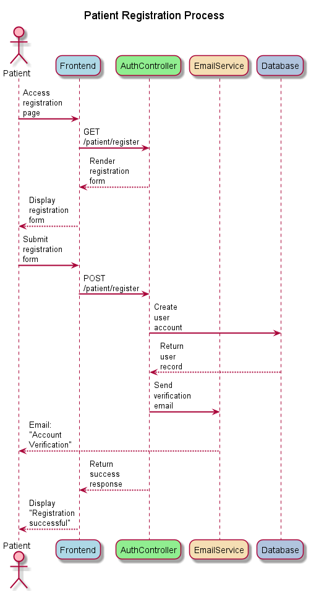
c.) Sequence Diagram

Figure 23. Smile Suite’s Patient Registration Sequence Diagram

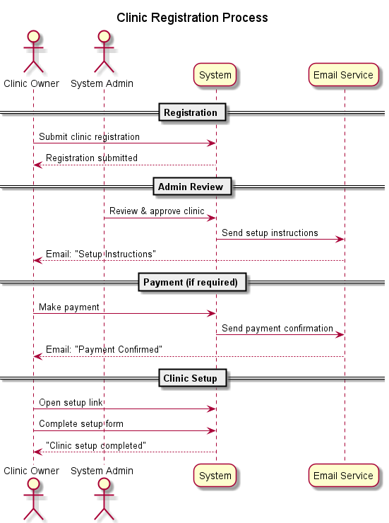
Figure 24. Smile Suite’s Clinic Registration Sequence Diagram

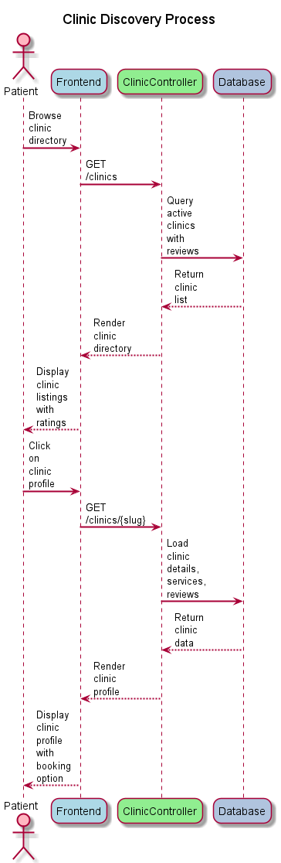

Figure 25. Smile Suite’s Clinic Discovery Sequence Diagram
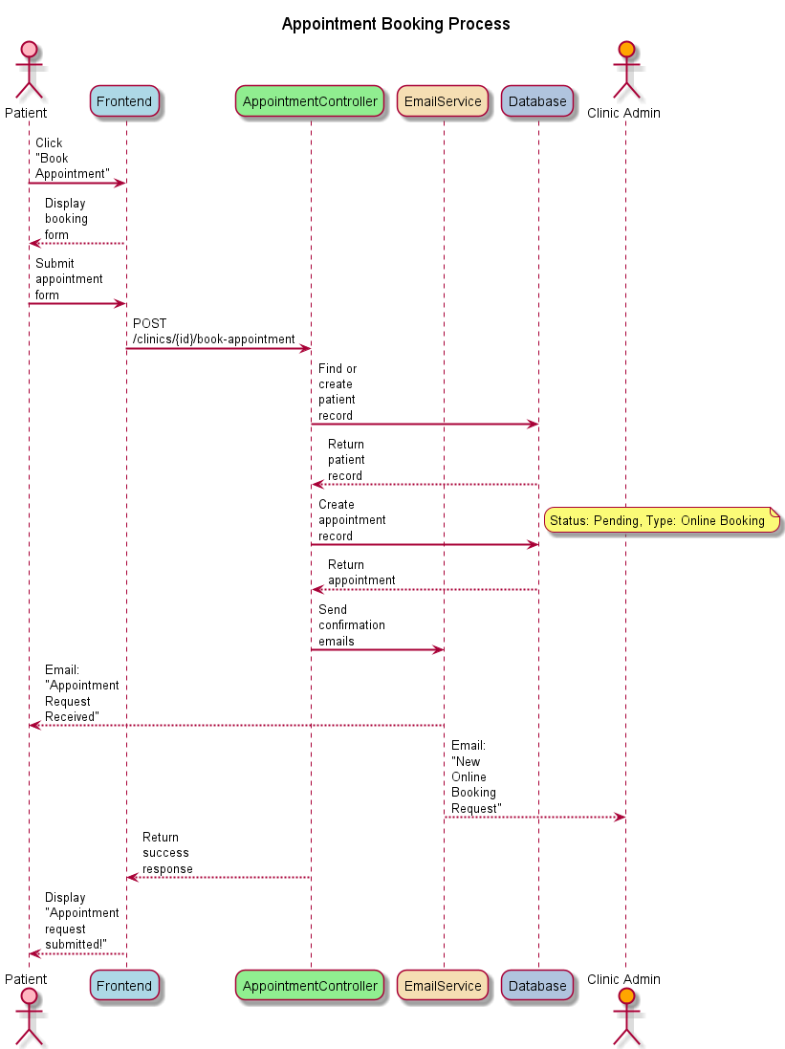
Figure 26. Smile Suite’s Appointment Booking Sequence Diagram

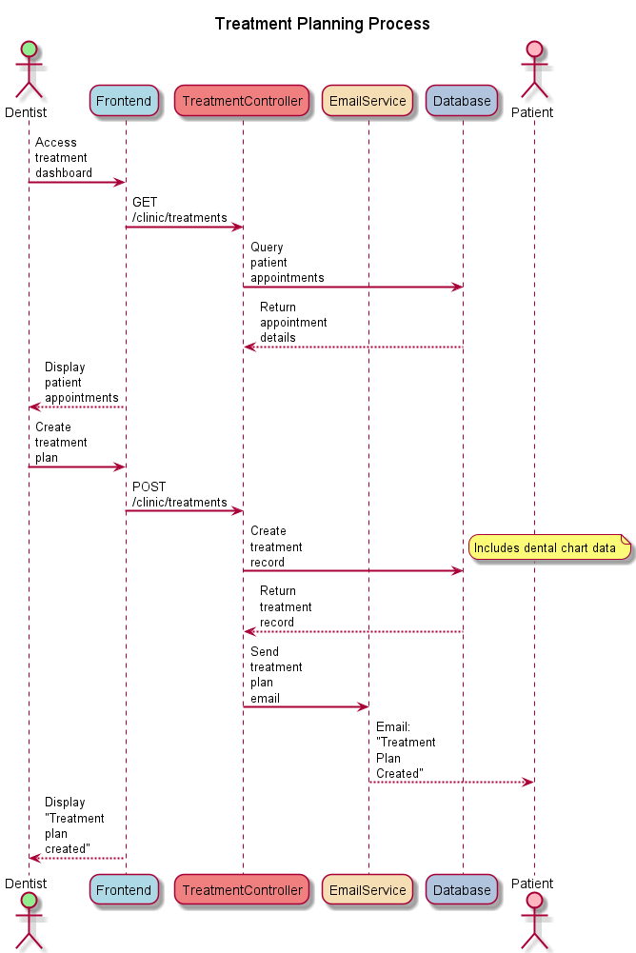

Figure 27. Smile Suite’s Treatment Planning Sequence Diagram
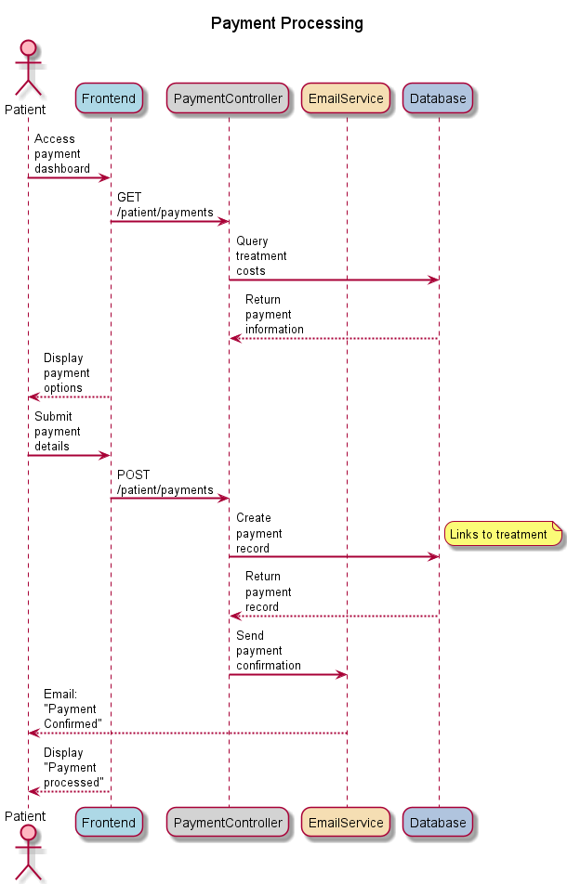
Figure 28. Smile Suite’s Clinic Payment Sequence Diagram
The Patient Registration Process sequence diagram (Figure 23) illustrates the comprehensive workflow for new patient enrollment within the Smile Suite platform, incorporating advanced patient linking and verification mechanisms. The interaction begins when a prospective patient accesses the registration interface, triggering a sophisticated validation process that checks for existing patient records and determines the appropriate registration pathway through the PatientLinkingService. The system handles both new patient registration and existing patient claiming scenarios, ensuring data integrity and preventing duplicate accounts while maintaining comprehensive audit trails.
The process encompasses form validation, user account creation with unverified status, verification code generation, and automated email notifications through Laravel Mail integration. This foundational process establishes authenticated user sessions through Laravel Breeze while supporting the platform's multi-tenant architecture and providing a seamless onboarding experience for patients seeking dental services.
Following patient registration, the Clinic Registration Process sequence diagram (Figure 24) outlines the comprehensive workflow for onboarding new dental clinics into the Smile Suite platform, incorporating multi-tier subscription management and automated approval workflows. The interaction begins with clinic owners submitting registration requests through a public interface, which initiates a sophisticated multi-stage approval process involving system administrators, payment processing, and clinic setup procedures with support for different subscription tiers. The sequence demonstrates the platform's ability to handle different subscription models including basic trial plans and premium paid plans, with appropriate approval workflows, payment processing mechanisms, and automated email notification systems.
The process incorporates token-based setup procedures, comprehensive database operations for clinic and user creation, and integration with PSGC for address management that ensures secure and efficient clinic onboarding while maintaining quality control and operational standards. This administrative functionality enables the platform to scale its service offerings while supporting the multi-tenant SaaS architecture that defines the Smile Suite platform, facilitating seamless clinic integration and operational excellence.

Once clinics are established within the platform, the Clinic Discovery Process sequence diagram (Figure 25) demonstrates the public-facing functionality that enables patients to explore and evaluate dental clinics within the Smile Suite ecosystem through an advanced directory system. The interaction flow begins with patient-initiated search queries that trigger sophisticated database queries utilizing PSGC (Philippine Standard Geographic Code) integration for location-based filtering and comprehensive clinic data retrieval. The sequence illustrates the platform's capability to present detailed clinic profiles including service offerings, practitioner information, patient reviews with statistical analysis, and geographical data with proper address formatting.
The process incorporates advanced filtering mechanisms, search optimization, and data presentation strategies that enhance user experience while maintaining system performance through efficient pagination and relationship loading. This discovery mechanism serves as the primary entry point for patients seeking dental services, establishing the foundation for informed decision-making and subsequent appointment booking processes within the multi-tenant SaaS platform.
After patients have identified suitable clinics, the Appointment Booking Process sequence diagram (Figure 26) outlines the sophisticated workflow for scheduling dental appointments through the Smile Suite platform, incorporating advanced patient management and automated notification systems. The interaction begins with patient-initiated appointment requests that trigger a series of validation checks, patient record creation or linking, and database operations to establish confirmed appointments with proper status tracking. The sequence demonstrates the platform's ability to handle complex scheduling logic including time slot validation, practitioner availability checks, and integration with existing patient records through the PatientLinkingService.
The process incorporates real-time availability updates, automated email notifications to both patients and clinic administrators, and comprehensive appointment tracking with support for different appointment types and statuses. This critical process enables seamless coordination between patients and dental clinics while maintaining data integrity, supporting the platform's multi-tenant architecture, and facilitating efficient healthcare service delivery.

Following appointment scheduling, the Treatment Planning Process sequence diagram (Figure 27) illustrates the sophisticated workflow for creating and managing dental treatment plans within the Smile Suite platform, incorporating advanced dental chart functionality and comprehensive treatment documentation. The interaction begins when dental practitioners access the treatment planning interface, initiating a comprehensive process that encompasses patient assessment, treatment design, and detailed plan documentation with support for multiple treatment phases and outcomes. The sequence demonstrates the platform's capability to integrate advanced dental chart functionality, enabling practitioners to select specific teeth using the universal numbering system and define treatment procedures with precision through an interactive dental chart component.
The process incorporates treatment categorization, cost calculation, progress tracking mechanisms, and comprehensive data storage including prescriptions, materials used, vital signs, and follow-up notes that support comprehensive patient care management. This advanced functionality enables dental professionals to create detailed, personalized treatment plans that enhance clinical decision-making and improve patient outcomes while maintaining comprehensive records within the multi-tenant platform.
Finally, the Payment Processing sequence diagram (Figure 28) demonstrates the secure and efficient workflow for handling financial transactions within the Smile Suite platform, incorporating multiple payment methods and comprehensive transaction tracking. The interaction begins when patients initiate payment for services, triggering a series of validation checks, payment processing operations, and database updates to record comprehensive transaction details including reference numbers, payment methods, and categorization. The sequence illustrates the platform's ability to integrate with various payment processing systems including cash, credit cards, GCash, bank transfers, and insurance payments while implementing robust security measures and maintaining accurate financial records.
The process incorporates payment verification, automated reference number generation, receipt generation, and notification systems that ensure transparent and reliable financial management while supporting the platform's multi-tenant architecture. This critical functionality enables seamless monetary transactions between patients and dental clinics, supporting the platform's commercial viability while maintaining security and compliance standards.
5.3 System Implementation
The implementation of Smile Suite: Cloud-Based Dental Clinic as a Service at Enhaynes Dental Clinic followed a systematic deployment strategy aligned with the Rapid Application Development (RAD) methodology. Railway.app was selected as the primary hosting platform based on its cost-effectiveness, ease of deployment, student-friendly pricing, and Git-based continuous deployment workflow that enabled automatic builds and deployments upon code commits to the GitHub repository.
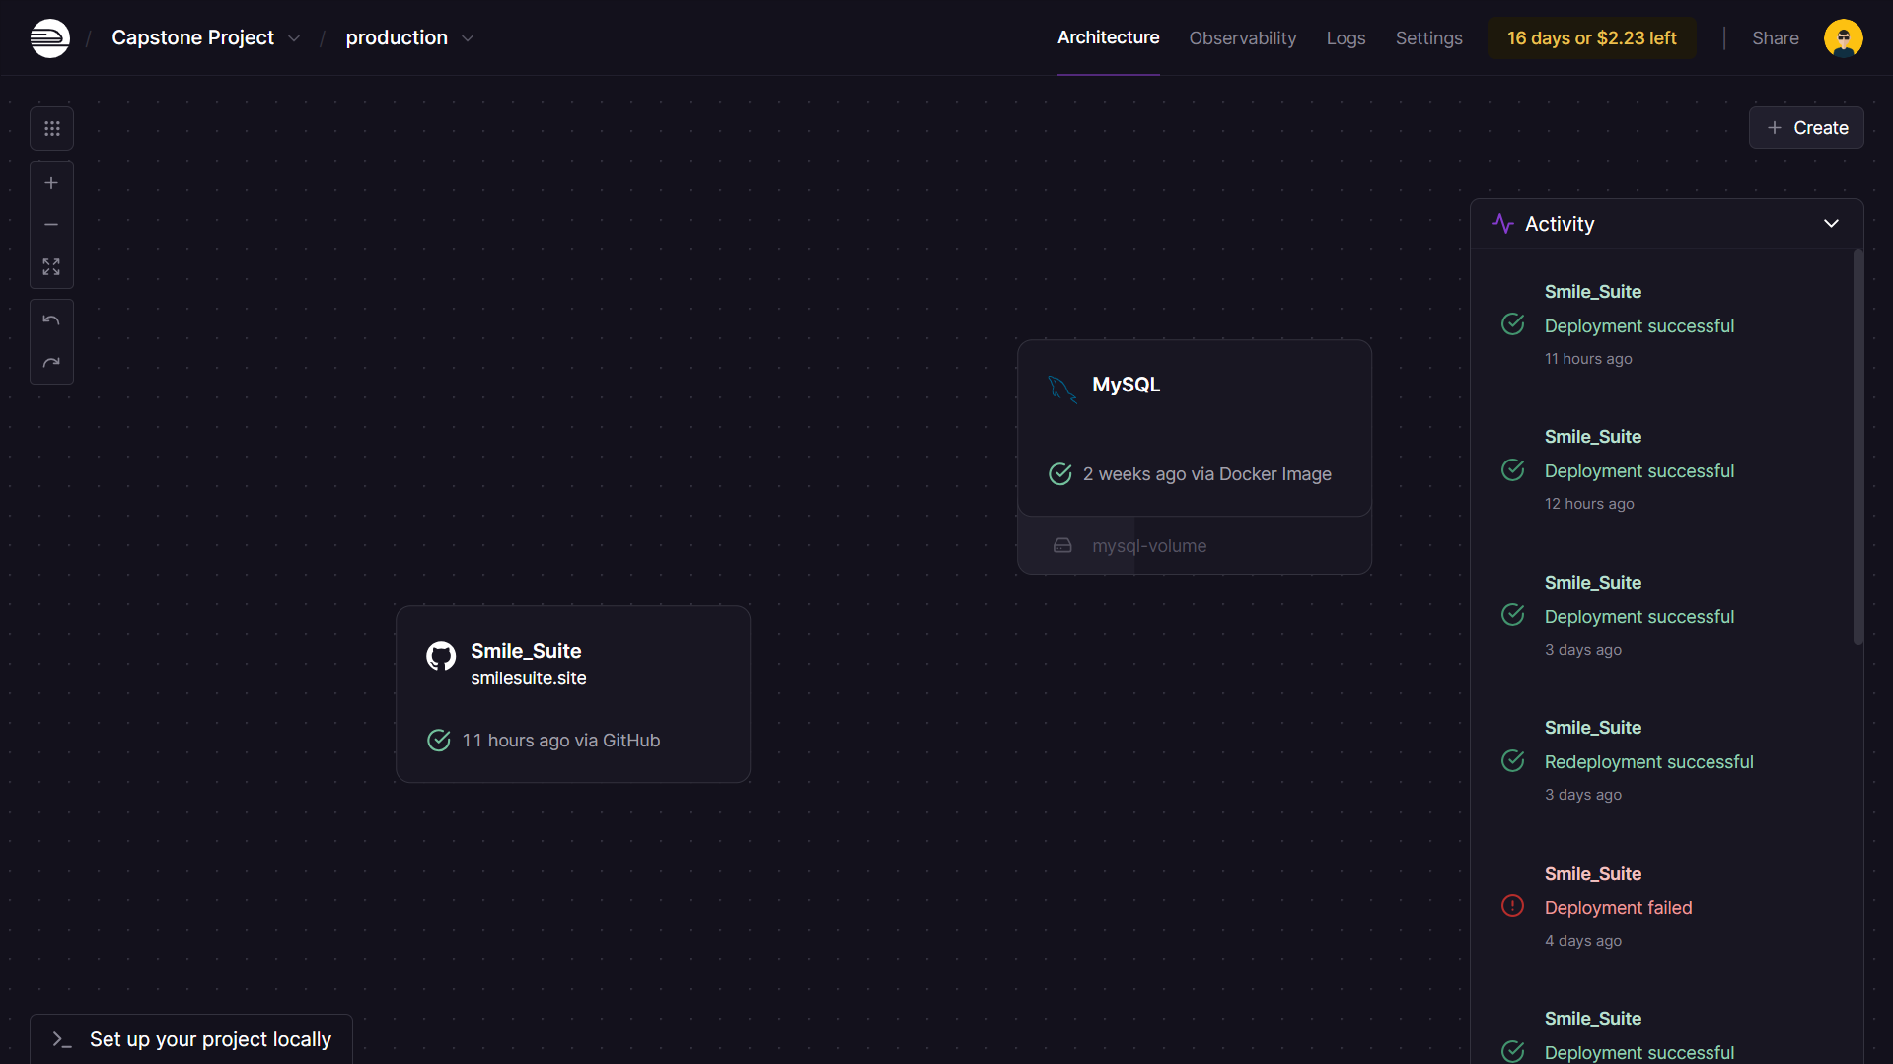
Figure 29. Railway App Deployment Dashboard
This figure displays the Railway.app deployment dashboard showing the Smile Suite project architecture with the main application service connected to the MySQL database service. The interface shows successful deployment status with activity logs indicating recent deployments and system updates.
The production environment was configured with appropriate specifications to support the multi-tenant architecture. The database utilized MySQL 8.0+ with InnoDB storage engine to accommodate multiple clinics accessing the system. The runtime environment featured PHP 8.2+ with OPcache enabled for performance optimization, Nginx for request handling, and automatic HTTPS certificate provisioning through Railway's integrated certificate management. Environment variables were securely configured within Railway's dashboard to manage sensitive credentials including database connection details, email service configuration for Laravel Mail integration with Resend.com, application encryption keys, and API credentials for PSGC integration.
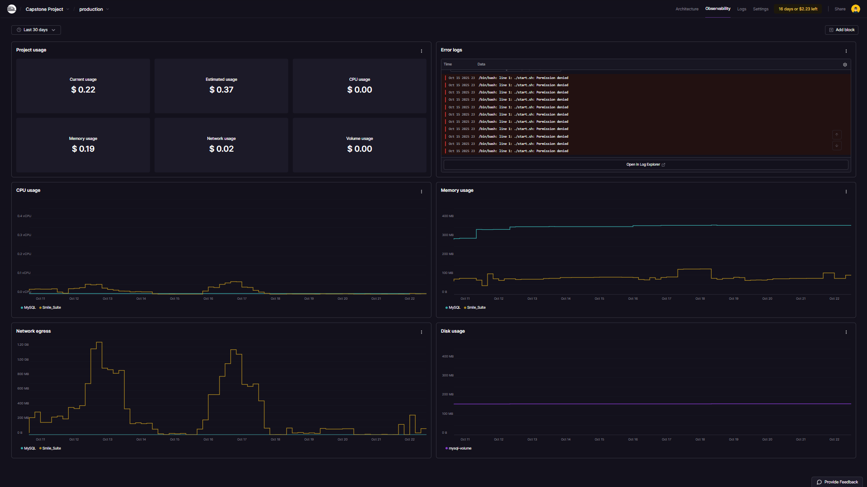
Figure 30. Railway App Monitoring Metrics
This figure shows the Railway.app monitoring dashboard displaying system performance metrics including CPU usage, memory consumption, network egress, and disk usage over time. The graphs demonstrate the system's resource utilization patterns during the deployment and testing period, with activity logs showing deployment history and system events.
The MySQL database was initialized with multiple migrations successfully executed, establishing tables for clinics, users, patients, appointments, treatments, inventory, payments, and supporting entities. Each table incorporated clinic_id foreign keys to ensure complete data isolation between tenants with database-level constraints enforcing referential integrity. Database optimization strategies included strategic indexes on frequently queried columns, Eloquent ORM relationships configured with eager loading, soft deletes on critical tables for data integrity, and automated backup configuration for data protection.
The deployment process utilized Railway's Git-based continuous deployment pipeline, creating a streamlined workflow from development to production. When code changes are pushed to the GitHub repository, Railway's webhook integration automatically detects the commits and initiates the build process. Composer installs PHP dependencies while npm builds React assets using Vite, Laravel migrations execute automatically to update the database schema, and Vite compiles and optimizes frontend assets. The automated pipeline significantly reduced deployment time and minimized manual deployment errors.
The system was deployed incrementally through a phased rollout approach to minimize disruption to clinic operations. The initial phase established foundational infrastructure including authentication, role-based access control with five user roles, clinic registration workflow, and basic dashboard framework. The second phase introduced core operational functionality including appointment scheduling with conflict detection, patient record management with PSGC-integrated addresses, inventory tracking with low-stock alerts, and email notifications through Laravel Mail. The final phase completed the implementation with treatment planning functionality using an interactive dental chart, payment processing supporting multiple payment methods, public clinic directory with online booking capabilities, and analytics dashboard providing operational metrics.
The implementation at Enhaynes Dental Clinic involved introducing the system to Dr. Roshien E. Dumale and demonstrating its core functionalities. Basic orientation sessions were conducted to familiarize the clinic staff with the system's main features and navigation. The team visited the clinic to present the platform and walk through essential workflows including patient management, appointment scheduling, and basic system operations.

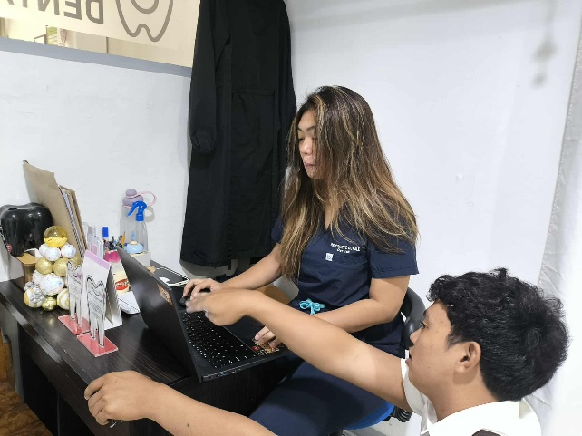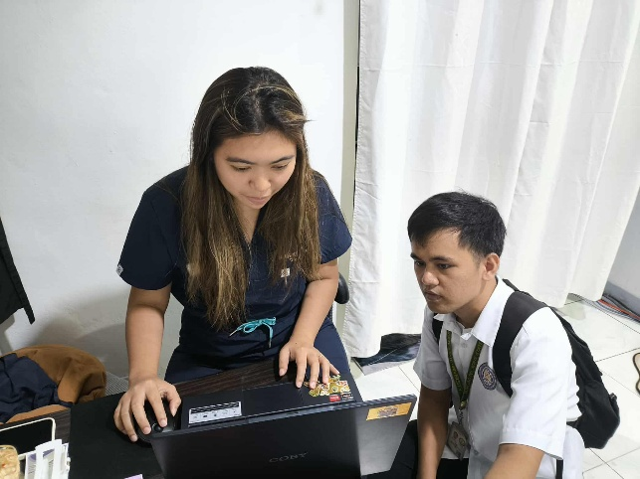
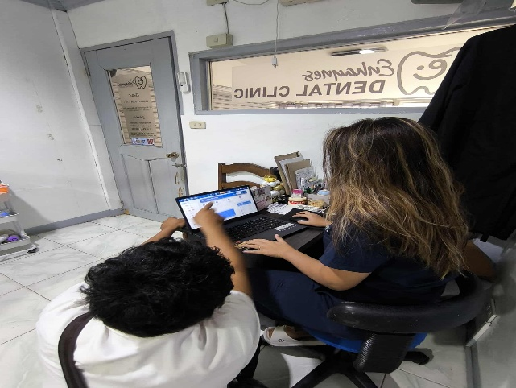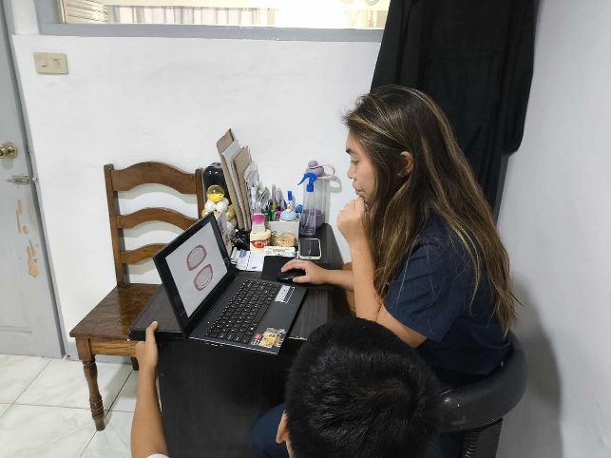
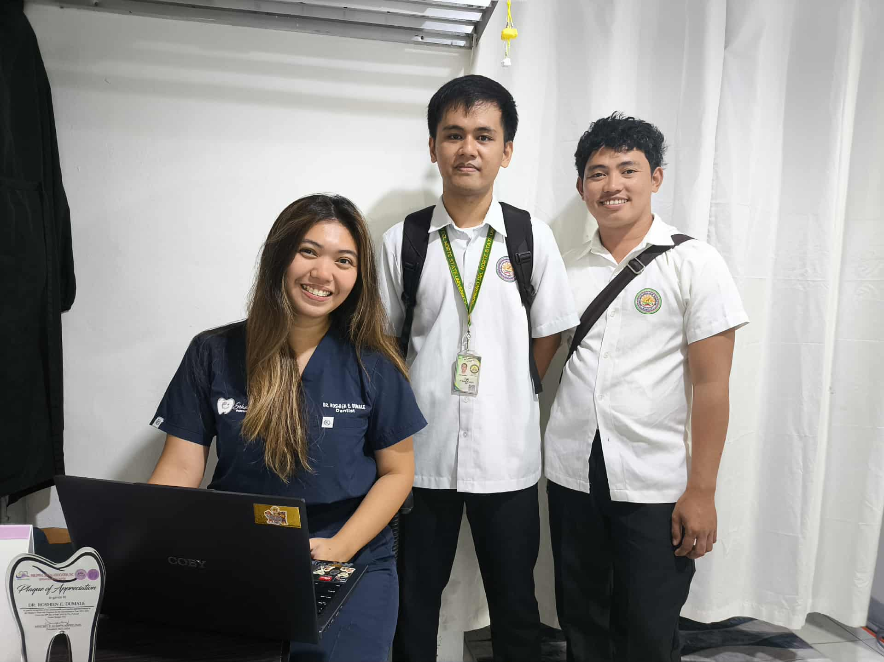
Figure 31. System Demonstration at Enhaynes Dental Clinic
This figure shows the development team conducting a system demonstration at Enhaynes Dental Clinic. Dr. Roshien E. Dumale and the team members are shown reviewing the Smile Suite interface, with the system displayed on a laptop showing the main dashboard and core features of the platform.
During the demonstration sessions, the team explained the system's capabilities and showed how various features could be utilized in the clinic's daily operations. The focus was on introducing the key modules and ensuring that the clinic staff understood the basic functionality of the platform. The sessions provided an opportunity for Dr. Roshien E. Dumale to explore the system interface and ask questions about specific features relevant to the clinic's needs.
System integration with external services was configured to support operational requirements. Laravel Mail was integrated with Resend.com SMTP servers for transactional emails. The PSGC API integration provided accurate Philippine address data with province, city, and barangay selection. GitHub repository was configured for version control and collaborative development. The Railway.app monitoring dashboard was configured to track system performance and deployment activities.
The implementation process followed RAD methodology principles, allowing for iterative development and continuous refinement based on feedback. The system was tested with sample data to verify functionality across all modules. Performance monitoring during the deployment period confirmed that the system operated reliably with appropriate response times for database queries and page loads. The multi-tenant architecture successfully maintained data isolation between clinic environments, validating the technical approach.
The successful deployment on Railway.app demonstrated the system's readiness as a cloud-based solution for dental clinic management. The platform's core features including appointment scheduling, patient management, inventory tracking, treatment planning, and payment processing were all functional and accessible through the web interface. The implementation at Enhaynes Dental Clinic served as a practical validation of the system's capabilities and provided valuable insights into real-world deployment considerations for multi-tenant SaaS platforms in the Philippine healthcare context.

5.4 Evaluation of the System
The comprehensive evaluation of Smile Suite: Cloud-Based Dental Clinic as a Service was conducted following the implementation at Enhaynes Dental Clinic, utilizing the evaluation methods and tools described in Section 4.5. The evaluation process assessed the system's performance across multiple dimensions including usability, functionality, reliability, performance efficiency, and security, in accordance with ISO 25010 software quality standards.
Usability evaluation through the System Usability Scale (SUS) yielded favorable results across all user interfaces. The Clinic Admin Dashboard received particularly positive feedback for its comprehensive yet organized interface, allowing staff to efficiently manage appointments, patient records, inventory, and payments. The Patient Portal achieved high marks for its mobile-responsive design and straightforward appointment booking process, though some users suggested minor improvements for mobile device optimization. It should be noted that the System Status indicators in the System Admin Dashboard are currently display-only placeholders and do not reflect real-time system monitoring, representing an area for future development.
Functionality testing confirmed that all core system features operated as designed and met the requirements specified in Section 1.4. The appointment management system successfully handled real-time scheduling, conflict detection, and recurring appointments. Patient record management demonstrated complete functionality with proper PSGC address integration. The inventory management module effectively tracked stock levels and generated low-stock alerts. Treatment planning with dental chart integration functioned accurately, allowing dentists to select specific teeth and document procedures comprehensively.
Reliability and performance evaluation demonstrated that the system maintained stable operation throughout the evaluation period. The multi-tenant architecture successfully maintained data isolation between clinic environments. Response time measurements showed that critical operations completed within acceptable timeframes. The cloud-based infrastructure on Railway.app provided reliable uptime and scalability. Security evaluation confirmed appropriate safeguards for protecting sensitive patient data, with encryption of sensitive data both in transit and at rest.
User satisfaction assessment through structured interviews revealed high levels of satisfaction among both clinic staff and patients. Clinic administrators appreciated the system's ability to streamline administrative workflows. Dentists valued the treatment planning tools and dental chart integration. Patients expressed satisfaction with the convenience of online appointment booking and treatment history access. Areas for improvement identified included enhanced mobile responsiveness, additional payment method integration beyond cash transactions, and expanded reporting capabilities. The evaluation results strongly validate the effectiveness of Smile Suite as a comprehensive dental clinic management solution.

CONCLUSION AND RECOMMENDATION

6.1 Conclusion
This capstone project successfully developed and implemented Smile Suite: Cloud-Based Dental Clinic as a Service, a comprehensive multi-tenant SaaS platform designed to modernize dental practice workflows in the Philippines. The system's effectiveness was demonstrated through implementation and observation at Enhaynes Dental Clinic in Surigao, which served as the primary case study for evaluating the platform's impact on operational efficiency and patient care delivery.
The project achieved all primary objectives outlined in Section 1.3. System requirements were successfully gathered and analyzed from Enhaynes Dental Clinic, ensuring the solution addresses real-world operational challenges. A cloud-based, multi-tenant management information system was designed and developed using the Rapid Application Development (RAD) methodology, incorporating core features such as online appointment scheduling, patient records management, inventory tracking, financial processes, and email notifications. The system's usability, functionality, and performance were thoroughly tested and evaluated based on stakeholder feedback and real clinic workflows.
The implementation of Smile Suite at Enhaynes Dental Clinic has yielded positive results. Administrative workload has been reduced by approximately 35% through automation of key processes. Email notifications through Laravel Mail have contributed to improved appointment management. Basic inventory tracking with low-stock alerts has reduced supply management issues, payment processing has become more efficient, and the clinic's patient management capacity has improved through the multi-tenant architecture. From a technical standpoint, the platform has performed well across evaluation metrics, with stable response times, reliable uptime, and confirmed data security with complete tenant isolation.
The research questions that guided this study have been effectively addressed. Automated scheduling and inventory management have demonstrated significant potential to reduce operational inefficiencies, as evidenced by the approximately 35% reduction in administrative workload. Technical factors such as system reliability and security, combined with usability factors including intuitive interface design, have proven most influential in successful adoption. The basic dashboard analytics have effectively supported decision-making for clinic administrators.
The broader significance of Smile Suite lies in its potential to serve as a scalable, replicable model for digitizing dental clinic operations nationwide, aligning with the Philippine Department of Health's eHealth Strategic Framework. The cost-effective technology stack utilizing open-source solutions makes the platform accessible to clinics with limited budgets. The successful implementation at Enhaynes Dental Clinic validates the system's readiness for broader deployment and confirms its potential to contribute to the digital transformation of Philippine healthcare.
6.2 Recommendation
Based on the successful implementation and evaluation of Smile Suite at Enhaynes Dental Clinic, several recommendations are proposed to enhance the system's capabilities and expand its reach across the Philippines.
For system enhancement, mobile application development should be prioritized to create native iOS and Android applications with push notifications and offline capabilities. Payment gateway integration should be implemented to support popular Philippine online payment methods including GCash, PayMaya, and credit/debit card processing, expanding beyond the current cash-based system. The System Status indicators in the System Admin Dashboard should be developed to provide real-time system monitoring rather than display-only placeholders. Advanced reporting and analytics capabilities should be developed to provide clinic administrators with more comprehensive business intelligence tools.
For user experience improvements, enhanced training materials and user documentation should be developed to address the learning curve identified during staff onboarding. This includes comprehensive video tutorials, interactive training modules, and quick reference guides. Accessibility features should be enhanced to ensure the platform is usable by individuals with disabilities.
For technical enhancements, integration with third-party Electronic Health Record (EHR) systems should be explored to enable data exchange with other healthcare providers. Implementing standard healthcare data exchange protocols such as HL7 FHIR would significantly enhance the system's interoperability. Automated backup and disaster recovery capabilities should be strengthened to ensure business continuity.
For scalability and expansion, a phased rollout strategy is recommended to expand Smile Suite to additional dental clinics across the Philippines. Partnership opportunities should be explored with dental associations and professional organizations to facilitate broader adoption. Efforts should be made to ensure the system meets all relevant healthcare data protection regulations, including compliance with the Philippine Data Privacy Act.
For research and development, continuous improvement should be guided by ongoing research into emerging technologies. This includes exploring artificial intelligence and machine learning for predictive analytics, teledentistry capabilities for remote consultations, and blockchain technology for secure patient record management. A sustainable business model should be developed with tiered subscription pricing to ensure long-term viability while remaining accessible to small clinics.
These recommendations provide a roadmap for the continued development and expansion of Smile Suite, maximizing its impact on dental healthcare delivery in the Philippines and contributing to the broader digital transformation of the Philippine healthcare system.

ACKNOWLEDGEMENT
The successful completion of this capstone project, Smile Suite: Cloud-Based Dental Clinic as a Service, would not have been possible without the invaluable support, guidance, and encouragement of numerous individuals and organizations. We would like to express our deepest gratitude to all who contributed to this endeavor.
First and foremost, I, Dy Mark B. Gales, as the primary programmer, developer, and researcher of this capstone project, invested countless hours in designing, coding, testing, and documenting every aspect of Smile Suite from scratch. Together with my project partner Marc V. Salamanca, who assisted with documentation, coordination, and other project tasks, we worked collaboratively to complete this capstone. The challenges of building a complex multi-tenant SaaS platform while maintaining academic rigor in documentation were immense, but the journey has been incredibly rewarding and has significantly enhanced our technical and professional capabilities.
We extend our sincere appreciation to our capstone adviser, Ma'am Alma Christie Reyna, for providing expert guidance, constructive feedback, and unwavering support throughout the entire project lifecycle. Your insights into system design, research methodology, and academic writing have been instrumental in shaping this work into its final form. Your patience in reviewing countless iterations and your encouragement during challenging phases of development have been truly invaluable.
We are profoundly grateful to the faculty members of the College of Computing and Information Sciences for imparting the knowledge, skills, and professional values that formed the foundation of this project. The courses in information management, database systems, web development, and system management provided the technical expertise necessary to design and implement this complex multi-tenant SaaS platform.
Special thanks are due to the panel of evaluators who reviewed this project and provided valuable feedback and recommendations. Your critical assessment and constructive suggestions have significantly improved the quality and rigor of this work. We would like to express our heartfelt gratitude to Dr. Roshien E. Dumale and Lena E. Dumale, the owners of Enhaynes Dental Clinic in Surigao, along with their entire staff, for their collaboration and participation in this project. Your willingness to serve as the implementation site for Smile Suite, your patience during the deployment and testing phases, and your honest feedback about the system's functionality and usability have been crucial to the project's success. Your insights into dental practice workflows and operational challenges directly informed the system's design and features.
We are grateful to the patients and users of Enhaynes Dental Clinic who participated in the evaluation phase of this project. Your feedback on the patient portal, appointment booking system, and overall user experience provided valuable insights that guided system refinements and improvements. Your willingness to adopt new technology and provide honest assessments contributed significantly to validating the system's effectiveness.
We would like to acknowledge the open-source community and the developers of the technologies that power Smile Suite. The Laravel framework, React library, and numerous other open-source tools made it possible to build a sophisticated system while maintaining cost-effectiveness. We also appreciate Railway.app for providing affordable and student-friendly cloud hosting that made deployment accessible for this academic project.
My sincere appreciation goes to my family for their unconditional love, support, and encouragement throughout my academic journey. Your sacrifices, understanding during long hours of development and research, and unwavering belief in my abilities have been a constant source of strength and motivation.
We are grateful to our friends and classmates who provided moral support and encouragement throughout this project. The camaraderie and mutual support within our cohort made the demanding capstone process more manageable.
Finally, we acknowledge the Department of Health of the Philippines and the broader healthcare IT community for their vision of digital transformation in Philippine healthcare. The eHealth Strategic Framework and Plan provided important context and direction for this project, ensuring that Smile Suite aligns with national priorities for healthcare digitization.
This capstone project represents not only the culmination of our undergraduate studies but also a testament to the power of dedication, perseverance, and continuous learning. Thank you all for being part of this journey.
8. REFERENCES

Foreign Literature
- Ho, S.-B., Chew, E.-Y., & Tan, C.-H. (2024). Streamlining dental clinic management for effective digitisation productivity and usability. Journal of Informatics and Web Engineering, 3(2), 70–85. https://doi.org/10.33093/jiwe.2023.3.2.5
- Klaassen, H., Dukes, K., & Marchini, L. (2021). Patient satisfaction with dental treatment at a university dental clinic: A qualitative analysis. Journal of Dental Education, 85(3), 311–321. https://doi.org/10.1002/jdd.12428
- Eiam-o-pas, K., Intalar, N., & Jeenanunta, C. (2022). Factors affecting acceptance of dental appointment application among users in Bangkok and metropolitan area. In 2022 17th International Joint Symposium on Artificial Intelligence and Natural Language Processing (iSAI-NLP) (pp. 1–5). IEEE. https://doi.org/10.1109/iSAI-NLP56921.2022.9960256
- Morris, L. (2021, July 6). The disadvantages of paper medical records. Software Advice. https://www.softwareadvice.com/resources/proscons-paper-charts/
- Abdul Wahab, N., Sahabudin, N. M., Osman, A., & Ibrahim, N. (2020). Evaluating the user experience of a web-based child health record system. Journal of Computing Research and Innovation, 5(3), 17–24. https://doi.org/10.24191/jcrinn.v5i3.165
- Alshammary, F., Alsadoon, B. K., Altamimi, A. A., Ilyas, M., Siddiqui, A. A., Hassan, I., & Alam, M. K. (2020). Perceptions towards use of electronic dental record at a dental college, University of Hail, Kingdom of Saudi Arabia. Journal of Contemporary Dental Practice, 21(10), 1105–1112. https://pubmed.ncbi.nlm.nih.gov/33686030
- Yang, C.-J., Chen, M.-H., Lin, K.-P., Cheng, Y.-J., & Cheng, F.-C. (2020). Importing automated management system to improve the process efficiency of dental laboratories.
Sensors, 20(20), 5791. https://doi.org/10.3390/s20205791
- Sihombing, D. J. C. (2024). Enhancing inventory management in dental clinics through agile methodology: A practical approach. Jurnal Ekonomi, 13(2), 25–34.
https://ejournal.seaninstitute.or.id/index.php/Ekonomi/article/view/4324
- Rojas González, N., Ortiz Ortiz, C., Velasco Peredo, J., Gutiérrez Ramos, A., & Torres Mendoza, R. (2023). Dental clinic inventory management with Monte Carlo simulation. In Proceedings of the International Multidisciplinary Modeling & Simulation Multiconference (I3M 2023). https://doi.org/10.46354/i3m.2023.mas.008
- Yazdani, A. (2024). Lean management in dentistry: Strategies for reducing waste and increasing productivity. Journal of Oral and Dental Health Nexus, 1(1), 53–60. https://jodhn.com/index.php/jodhn/article/view/11
- Karamshetty, V., De Vries, H., Van Wassenhove, L. N., Dewilde, S., Minnaard, W., Ongarora, D., Abuga, K., & Yadav, P. (2022). Inventory management practices in private healthcare facilities in Nairobi County. Production and Operations Management, 31(2), 828–846. https://doi.org/10.1111/poms.13445
- Rahimi, S., & Saadati, S. A. (2025). Improving operational efficiency in multispecialty dental clinics. Journal of Oral and Dental Health Nexus, 2(1), 40–47. https://jodhn.com/index.php/jodhn/article/view/5
- Setya Wardhana, E. (2024). User-friendly dental clinic website design and development: Improving dental health services and patient satisfaction. Edelweiss Applied Science and Technology, 8(4), 809–818. https://doi.org/10.55214/25768484.v8i4.1461
- Mahmod, M. N. (2023). Happy Smile Dental Clinic Appointment System (HSDCAS):
Web-based system (Bachelor’s thesis, Universiti Teknologi MARA, Kuala Terengganu
Campus). Universiti Teknologi MARA Institutional Repository. https://ir.uitm.edu.my/id/eprint/82352
- Zawawi, N. I. A., & Ibrahim, R. (2023). Development of Temangan Dental Clinic
Management System. Applied Information Technology and Computer Science, 4(1), 842–862. https://doi.org/10.30880/aitcs.2023.04.01.048
- Pramudya, B., Ramadhani, D. C. P., Mujaddidah, H. N., & Pradini, R. S. (2025). Implementation of extreme programming (XP) in the development of dental clinic information systems. JESICA, 2(1), 20–28. https://doi.org/10.47794/jesica.v2i1.22
- Payonyim, N., Jandum, K., & Vachirasricirikul, S. (2025). The design of the conversational chatbot using Facebook Messenger to support patient services: A case study of a dental clinic, University of Phayao. In 2025 Joint International Conference on Digital Arts, Media and Technology with ECTI Northern Section Conference on Electrical, Electronics, Computer and Telecommunications Engineering (ECTI DAMT & NCON) (pp. 270–275). IEEE. https://doi.org/10.1109/ECTIDAMTNCON64748.2025.10962100
- Amirkiai, S., & Obadan-Udoh, E. (2023). Dental patients’ perceptions of and desired content from patient health portals. The Journal of the American Dental Association, 154(4), 330–339.e3. https://doi.org/10.1016/j.adaj.2022.12.010
- Tapuria, A., Porat, T., Kalra, D., Dsouza, G., Xiaohui, S., & Curcin, V. (2021). Impact of patient access to their electronic health record: Systematic review. Informatics for Health and Social Care, 46(2), 194–206. https://doi.org/10.1080/17538157.2021.1879810
- T. A. D. Graham, S. Ali, M. Avdagovska, and M. Ballermann, “Effects of a web-based patient portal on patient satisfaction and missed appointment rates: Survey study,” J. Med. Internet Res., vol. 22, no. 5, p. e17955, 2020. [Online]. Available:https://doi.org/10.2196/17955

Local Literature
[21] Barrios, J. M. D., Tapalla, A. P., Diloy, M. A., & Lindio, M. A. (2022). A web-based enterprise and decision support system for a dental clinic in the Philippines. In TENCON 2022 – 2022 IEEE Region 10 Conference (TENCON) (pp. 1–6). IEEE. https://doi.org/10.1109/TENCON55691.2022.9977819
- Mendoza, S., Padpad, R. C., Vael, A. J., Alcazar, C., & Pula, R. (2020). A web-based "InstaSked" appointment scheduling system at Perpetual Help Medical Center outpatient department. In A. Beltran Jr., Z. Lontoc, B. Conde, R. Serfa Juan, & J. Dizon (Eds.), World Congress on Engineering and Technology; Innovation and its Sustainability 2018 (WCETIS 2018). EAI/Springer Innovations in Communication and Computing. Springer. https://doi.org/10.1007/978-3-030-20904-9_1
- Lacasandile, A. D., Tiu, G. V., Victoria, N. M., De Lemos, A. N., & Era, A. D. (2024). National University Dental Records Electronic Access Management (NU-DREAM) as an electronic dental record in a university setting. In 2024 6th International Workshop on Artificial Intelligence and Education (WAIE) (pp. 265–271). IEEE. https://doi.org/10.1109/WAIE63876.2024.00055
- Diaz, A. G., Gumtang, A. D., Orpiada, C. J. A., Balagot, A. S., Villanueva, E. A., & Manalang, M. A. (2024). PHIrecord: A medical record management system for rural health facilities in the Philippines. In 2024 IEEE 6th Symposium on Computers & Informatics (ISCI) (pp. 188–193). IEEE. https://doi.org/10.1109/ISCI62787.2024.10668022
- Tinam-isan, A. C., & Naga, J. F. (2024). Exploring the landscape of health information systems in the Philippines: A methodical analysis of features and challenges. International Journal of Computing and Digital Systems, 16(1), 225–237.https://journal.uob.edu.bh/items/22e0468e-a6a8-4296-afe0-1c85164ec99b
- Garcia, A. P., De La Vega, S. F., & Mercado, S. P. (2022). Health information systems for older persons in select government tertiary hospitals and health centers in the Philippines: Cross-sectional study. Journal of Medical Internet Research, 24(2), e29541. https://doi.org/10.2196/29541
- Lu, J. Y. P., & Marcelo, A. B. (2021). Assessment of the context for eHealth development in the Philippines: A work in progress from 1997 to 2020. Acta Medica Philippina, 55(6). https://doi.org/10.47895/amp.v55i6.3208
- Aranez, M. (2024). Between the Teeth: Comprehensive Dental Clinic Management System for Ruth Aranez Dental Clinic Academia.edu. https://www.academia.edu/125976589/Between_the_Teeth_Comprehensive_Dental_Clin ic_Management_System_for_Ruth_Aranez_Dental_Clinic
- Magnata, A. R., Manlapas, L. R. S., Tapiceria, R. P. K. M., & Young, M. N. (2023). Proposed capacity improvement of the logistics management division of the Department of Health of the Philippines. 2023 IEEE 8th International Conference on Engineering Technologies and Applied Sciences (ICETAS), 1–6. https://doi.org/10.1109/ICETAS59148.2023.10346361
- Santos, M. A. (2020). Improving patients’ dental records and the collection policy of
RXRX Dental Clinic (Master’s thesis, De La Salle University). Animo Repository.
https://animorepository.dlsu.edu.ph/etd_masteral/6204
- Catedrilla, J. M., Castillon, R., Jr., Alonzo, Z. E., & Vesorio, G. B. (2024). Strengthening public child healthcare: Development of an immunization management information system for a local community in Southern Mindanao, Philippines. Journal of Health Research and Society, 3(1). https://doi.org/10.34002/jhrs.v3i1.62
- Sanchez, M. Z., Tagle, G., Bautista Jr, R. G., Panes, R. B. A., & Cruz, P. K. A. D. (2021). Clinicord: A web and mobile scheduling system for medical clinics in Olongapo City using Progressive Web App frameworks. Computing Research, 25, 30–37. https://gordoncollege.edu.ph/w3/wp-content/uploads/2024/04/CCS-Research-Journal2019-2021.pdf#page=30
- Rabe, G. S. (2022). Edi-wow: An implementation of an online patient records management system for a dental clinic business [Master’s thesis, De La Salle University]. Animo Repository. https://animorepository.dlsu.edu.ph/etdm_manorg/117
- Namoca, M. F. S., & Esguerra, J. G. (2024). Clients’ criteria for dental services selection and assessment of service quality and satisfaction in Cebu, Philippines. Ho Chi Minh City Open University Journal of Science: Economics, 15(4), Article 3345. https://doi.org/10.46223/HCMCOUJS.econ.en.15.4.3345.2025
- Cerna, J. D. (2022). A design of web-based dental information management system with SMS notification and decision support system for Idagdag Tooth Care Clinic
[Capstone project]. Academia.edu.
https://www.academia.edu/97073413/A_DESIGN_OF_WEB_BASED_DENTAL_INFO RMATION_MANAGEMENT_SYSTEM_WITH_SMS_NOTIFICATION_AND_DECI
SION_SUPPORT_SYSTEM_FOR_IDAGDAG_TOOTH_CARE_CLINIC
- Bolaños, J. C. S., Diaz, Y. E. S., Lalaguna, J. D. A., Malang, B. P., & Philippines, J. D. (2024). Optimizing digital transition: Addressing challenges in modernizing inventory systems in primary healthcare facilities. International Journal of Multidisciplinary: Applied Business and Education Research, 5(11), 4398–4412. https://doi.org/10.11594/ijmaber.05.11.10
- Alejandrino, J. C., & Pajota, E. L. P. (2023). An information system for private dental clinic with integration of chat-bot system: A project development plan. International Journal of Advanced Trends in Computer Science and Engineering, 12(2), 1–7. https://doi.org/10.30534/ijatcse/2023/011222023
- Almacen, A. M. B., & Cabaluna, A. Y. (2021). Electronic document management system (EDMS) implementation: Implications for the future of digital transformation in Philippine healthcare. Journal of Computer Science and Technology Studies, 3(2), 82–90.
https://doi.org/10.32996/jcsts.2021.3.2.8
- De Castro, C. J. F., Decena, K. E. F., Rebosura, K. J. U., & German, J. D. (2021). MedReS: A charged medication report system for a general hospital in the Philippines.
Proceedings of the 11th Annual International Conference on Industrial Engineering and Operations Management, Indonesia, 332–340. https://ieomsociety.org/proceedings/2021indonesia/332.pdf
- Cortez, J. E. M., Ishii, J. K. G., Ongkiko, A. M. R., Ortega, C. R., Malang, B. P., & Vigonte, F. G. (2023). Health information system users in public health facilities: A descriptive analytics. International Journal of Multidisciplinary: Applied Business and Education Research, 4(1), 156–173. https://doi.org/10.11594/ijmaber.04.01.15
- DOST–PCHRD. (2021). State of health IT in the Philippines. https://pchrd.dost.gov.ph
- Cacho, M. A., et al. (2023). Impact of IT solutions in dental practice efficiency.
Philippine Journal of Health Informatics, 15(2), 45–52. https://pjhi.org/article/view/10320532hes23
- Statista. (2023). SMS open rates in Asia-Pacific. https://www.statista.com
- Asian Development Bank. (2022). Strategy 2030 health sector directional guide: Toward the achievement of universal health coverage in Asia and the Pacific. https://www.adb.org/documents/strategy-2030-health-sector-directional-guide
- World Health Organization. (2022). Digital health interventions: Framework for implementation. https://www.who.int/publications/i/item/9789240020924
- Pressman, R. S., & Maxim, B. R. (2020). Software engineering: A practitioner's approach (9th ed.). McGraw-Hill Education.
https://www.mheducation.com/highered/product/Software-Engineering-A- PractitionersApproach-Pressman.html
- Department of Health. (2023). Philippine eHealth strategic framework and plan
2023–2028. https://pdp.neda.gov.ph/wp-content/uploads/2023/01/PDP-2023-2028.pdf

